**Project Proposal**

**On**

**Online Book Ordering**

**Management System**



Submitted by: Submitted to:

Nimesh Poudel Niman Maharjan

00174397

Computing Project

Level 5 Diploma in Computing

Softwarica College of IT & E-Commerce

Kathmandu, Nepal

# **Chapter 1: Introduction**

## **Project Introduction**

My topic for the computing programming is "Online Book ordering management system" where a website is built for the organization Kitab Yatra. This website helps both the employee and the customers to interact each other very easily. This website is built to minimize the worries for the organization. Customers can easily get the desired books through this website. My website also consists books with its details. Also in my website the costumers can make their own account and give feedback to the organization about their facility. This helps the organization to do the work on the negative parts of their service and on the maintenance.



Figure 1: Website Structure

In the above figure it clearly shows that customers can sign in easily. Also they can learn about the services of the Kitab Yatra by looking at the about section. Also book can be found by the category.

My system is web based so it is build with the PHP and its supported tools. In this proposal I have also maintained the time taken to build this website in the valid time.

## **Justification for Project**

### **Background of project**

This project is built to give the excellent service to the book readers. As my project is the web based so it is very easy to use for the readers of our country. My website contains the books with their authors. It is built to maintain the fast home delivery service for books.

### **Problem Statement**

Nowadays readers are increasing very vastly in the country. As readers are increasing they want to read a various books. Also they want the book in their home by one click so that they should not go shop to buy books. Also they want the books of various categories. So by looking at this problem I decide to build the website in which all the books are available and also the books are shipped to the readers in minimum 24 hrs.

And my website in build in the best web programming language called PHP which can minimize the tons of errors. As the website is build by the student this doesn't bear any cost. But if this website will be built for the organization in the real life scenario it will cost some amount.

### **Proposed Solution**

For the solution I am building up the application from which the readers can easily buy the books of their own choices and enjoy reading. Website services will be 27*7 hours active so that reader won't get any issue in ordering the book.

To make the services better I have analyzed and visited some of the similar type of website which will more be helpful to me to learn and to build a complete book ordering website.

## **Description of Project**

### **Features**

* Online book service
* Have all categories of books
* Have well secured login system
* Feedback to the organization can be given
* High usability
* Interface of the website is easy to use

## **Overview of the project**

This project is build to give a well managed service to the book readers of their desired categories. My project is build by the help of PHP and its related tools to maintain the standard of the website. Project will be full concentrated on making the online book ordering management system which will in future give an ease facility to the book lovers.

As project will be web based it will be reliable and trustable.

# **Chapter 2: Scope of Project**

## **2.1) Scope**

* My project helps the readers to find the books of their desired categories.
* My project help the organization to get feedback on their services.
* This project will secure the customers ID
* Its gives the opportunity to readers to be engage with books

## **2.2) Limitations**

* To use some features user need the internet facilities
* Customer can only buy a one book at a time.
* This application need browser to open.

## **2.3) Aims**

* To give a quick services to the customers.
* To give a varied number of books to the customers.
* To help the readers to feel easy to buy a book staying at home or to make the effective way for the readers to reach books of their interest.

## **2.4) Objectives**

* To make a reading country.
* To add more number of readers in the country.

## **2.5) Overview of the Scope**

As my website is build with the help of the PHP and its supporting tools, also with the help of the HTML and CSS, it could be more easy to use by the customers of the person who click the website. As the data is stored in the MySQL, data is preserved and securely kept so that data are not lost in the future.

# **Chapter 3: Development Methodology**

There are different methodology of manufacturing the software. Some of them are iterative, extreme programming, waterfall, incremental development etc. But for my project I will choose that development methodology which will be beneficial for me throughout my completion of project.

## **3.1) Waterfall model**

I choose the methodology of developing my project with the help of Waterfall model because my project is a small and student project, and this type of project is develop to make a good example for others or to teach others. So for this type of project waterfall model is very much perfect. In the waterfall model every step should be completed and only move to the next step. As waterfall model is best for the small scale organization, I use this model for manufacturing my website. **WaterfallModel** illustrates the software development process in a linear sequential flow; hence it is also referred to as a **Linear-Sequential Life Cycle Model.*****(Toolsqa, 2019)***

There are some of the similar type of development methodology such as scrum, Agile, Spiral, etc. But I choose and stick with the waterfall model because of following reasons given below:

Comparison of waterfall model with Agile:

* Waterfall model is more rigid than that of agile model.
* In the waterfall model, before manufacturing the system all the requirement should be fulfilled and after the project starts there is no way of changing, so this will make the developer concentrated in the project from the starting phase.
* As the waterfall model is internal phase of developing, it doesn't require the customer's opinion so that this methodology is fruitful for my student project.

Comparison of waterfall model with Scrum:

* For my student project I need to complete to complete my work by me own. And in scrum the work is subdivided to the team members which I am not allowed for my project. So waterfall model is best for me in the development.
* In the scrum every step should be shown to the manager but in the case of waterfall it is self analysis and testing. So in this reasons too, it is best for me to carry on.

Comparison of waterfall with spiral:

* As talking about the waterfall model than that of spiral, waterfall model is started taking the minimum requirements than spiral, so the quick start is available for the waterfall model.
* The certain about of discipline about the waterfall model which is lack in the spiral makes waterfall model better than spiral methodology of development.

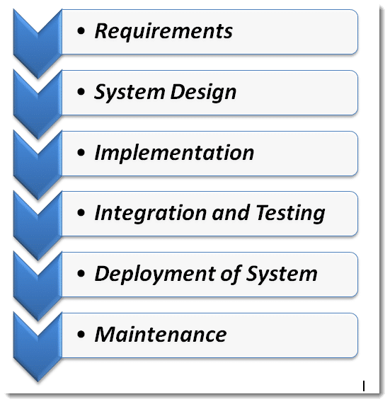

Figure 2: Waterfall model stages

## **3.2) Design pattern used**

Design pattern is a general repeatable solution to a commonly occurring problem in software design. ***(sourcemaking, 2019)***

Design patterns mainly help the development process to get in speed. Moreover, design patterns helps the developer to communicate by using the names for software interactions. For my project I decided to use the MVC pattern of designing.

### **Model view controller**

Model view controller is well recognized name in the development of the web based application. It is applied to separate the development of the application into 3 pieces and do the development process effectively and with ease.

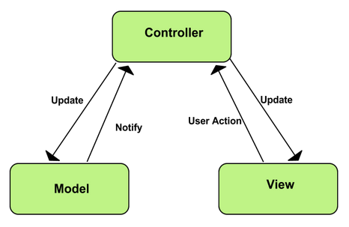

Figure 3: MVC pattern

There are many more design patterns such as web form, singleton, Proxy design pattern, etc. but I choose the MVC pattern because of following ways:

* Separation of Concerns:

MVC patterns give clean separation UI, data, model and the business logic.

* More control:

It have more control on the java, CSS and the HTLM than that of other design patterns. So as my application is web based it is better to use the MVC pattern.

* Testability:

MVC pattern provide more test options for the web based application than that of others. So it is very much fruitful to use the MVC rather than others such as Singleton, PDP, etc.

So due to this reasons I choose the MVC pattern over others.

## **3.3) System Architecture**

System Architecture is a framework that is comprised of the relationships and interactions between application components, such as middleware systems, user interfaces, and databases. ***(web-application-architecture, 2018)***

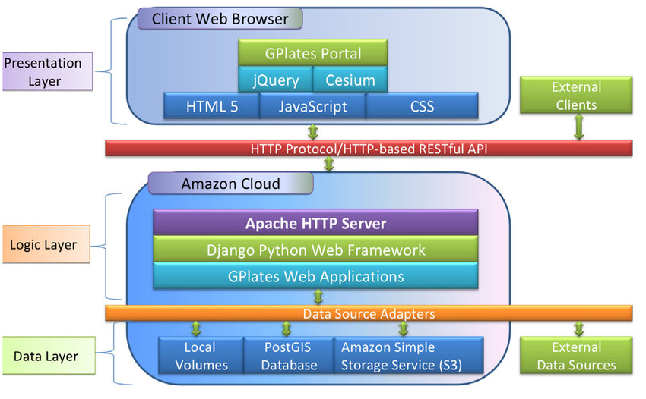

Figure 4: 3 tier System architecture

I choose the 3-Tier architecture over others because of following ways:

* It mainly gives an opportunity to develop the ability of updating the technology.
* Its gives the opportunity to work in the own expertise.
* It is more reliable than that of others.
* It provide the ease of maintaining the code.

# **Chapter 4: Project plan + Work Breakdown Structure**

## **4.1) Work Breakdown Structure**

I have planned my project to be done in the exact time. So to do that I must break down the works and separate the days for them. As my project is also an academic based so it have a deadline in which I must submit my work. So the WBS helps me to complete my work in the mean time.

To separate the time for each task, I must thoroughly analyze the task. In this analysis, I should calculate the days for each task according to their need. All the task don't contain the same amount of days.

Online Book ordering management System

Project Submission

White Box Testing

Black Box Testing

Integration Testing

Unit Testing

Coding

Building Database

Final Class Diagram

Database Design

UI Design

Behavioral Design

Class Diagram

Feasibility Study

NLA

Brainstorming

Use case Diagram

Requirement Specification

Configuration Management

Proposal Submission

Risk Management

Project Plan

Final Deadline

Testing

Analysis

Design

Implementation

Project Management

Ma

Work Breakdown Structure (WBS)

|  |  |  |
| --- | --- | --- |
| WBS | Task Name | No. Of Days |
| **0** | **Online Book Ordering Management System** | **108** |
| **1**  1.1  1.2  1.3  1.4 | **Project Management**  Project Plan  Risk Management  Configuration Management  Proposal Submission | **16**  7  4  4  1 |
| **2**  2.1  2.2  2.3  2.4  2.5  2.6 | **Analysis**  Requirement Specification  NLA  Use Case Diagram  Initial Class Diagram  Brainstorming  Feasibility Study | **28**  9  2  2  2  6  7 |
| **3**  3.1  3.2  3.3  3.4 | **Design**  Behavioral Design  UI Design  Database Design  Final Class Diagram | **25**  3  15  4  3 |
| **4**  4.1  4.2 | **Implementation**  Building Database  Coding | **20**  5  15 |
| **5**  5.1  5.2  5.3  5.4 | **Testing**  Unit Testing  Integration Testing  White Box Testing  Black Box Testing | **7**  2  2  2  1 |
| **6**  6.1 | **Final Deadline and Documentation**  Project Submission | **11**  11 |

Table: Tabular structure for WBS

## **4.2) Milestones**

Milestones are very necessary to a project for developing it in the mean time. All the programmers create a date for each task of their project to finish the project in the accurate time. Milestones helps developers or programmers to be in an advantage. So, for my project too, I have set some milestones.

|  |  |  |  |
| --- | --- | --- | --- |
| S.N. | Milestone | Date | Days |
| **1** | **Project Management**  Project Plan  Risk Management  Configuration  Proposal Submission | **3/25/19 8:00 AM to 4/9/19 5:00 PM**  3/25/19 8:00 AM to 3/31/19 5:00 PM  4/1/19 8:00 AM to 4/4/19 5:00 PM  4/5/19 8:00 AM to 4/8/19 5:00 PM  4/9/19 8:00 AM to 4/9/19 5:00 PM | **16**  7  4  4  1 |
| **2** | **Analysis**  Requirement Specification  NLA  Use Case Diagram  Class Diagram  Brainstorming  Feasibility Study | **4/10/19 8:00 AM to 5/7/19 5:00 PM**  4/10/19 8:00 AM to 4/18/19 5:00 PM  4/19/19 8:00 AM to 4/20/19 5:00 PM  4/21/19 8:00 AM to 4/22/19 5:00 PM  4/21/19 8:00 AM to 4/22/19 5:00 PM  4/23/19 8:00 AM to 4/28/19 5:00 PM  4/29/19 8:00 AM to 5/7/19 5:00 PM | **28**  9  2  2  2  6  7 |
| **3** | **Design**  Behavioral Design  UI Design  Database Design  Final Class Diagram | **5/8/19 8:00 AM to 6/1/19 5:00 PM**  5/8/19 8:00 AM to 5/10/19 5:00 PM  5/11/19 8:00 AM to 5/25/19 5:00 PM  5/26/19 8:00 AM to 5/29/19 5:00 PM  5/30/19 8:00 AM to 6/1/19 5:00 PM | **25**  3  15  4  3 |
| **4** | **Implementation**  Building Database  Coding | **6/2/19 8:00 AM to 6/21/19 5:00 PM**  6/2/19 8:00 AM to 6/6/19 5:00 PM  6/7/19 8:00 AM to 6/21/19 5:00 PM | **20**  5  15 |
| **5** | **Testing**  Unit Testing  Integration Testing  White Box Testing  Black Box Testing | **6/22/19 8:00 AM to 6/28/19 5:00 PM**  6/22/19 8:00 AM to 6/23/19 5:00 PM  6/24/19 8:00 AM to 6/25/19 5:00 PM  6/26/19 8:00 AM to 6/27/19 5:00 PM  6/28/19 8:00 AM to 6/28/19 5:00 PM | **7**  2  2  2  1 |
| **6** | **Final Deadline and Documentation**  Project Submission | **6/29/19 8:00 AM to 7/9/19 5:00 PM**  6/29/19 8:00 AM to 7/9/19 5:00 PM | **11**  11 |

Table: Milestone of the project

In the above milestone table, I have classified the days for each task. I have given a 16 days for Project management, analysis for 28 days, 25 days for design, and 20 days for implementation, 20 days for testing and to submit the final document for 11 days.

For Project management I have given 16 days because it is the initial stage of my project. In that section I must have a preplan and the discussion about my project. In that section I have divided some days on the 4 parts. That division is most important in my project.

Also, I have divide the 28 days for analysis. Analysis need a more days than others because it is the most important part of my project. Without the analysis project will be freeze down. So to get my project in speed in the future, I have separated the more days for that section.

For the design I have decided to give the 25 days. Design is also the important phase of my project. In that time I will deal with the UI design, database design, and will complete my final class diagram. For UI design I have given more days of the design section because UI is the face of any project. If face is attractive than it will be beneficial for the users to understand and to use it easily.

Similarly. For the implementation I have divided 20 days. As we all know that coding is the core part of any project. Without the coding the system doesn't run. So it needs more time to be implemented. So due to this reason I have separated the 20 days in the implementation section of my project.

Also, for the testing section I have given 7 days. Yes, off course for the testing developer will take more time, but as this is academic project and also it's not for the sale or the demanded project. So I have decided to complete my all test in the 7 days.

And at the last section of full documentation I have decided to give 11 days because the detail of my project will be in the final document so it need me more time to complete that. So due to that reason I have decided to give 11 days.

## **4.3) Schedule**

In this section of the project, I will divide the days and schedule them for my working days. So for scheduling I prepare the Gantt chart here for this project. A Gantt chart, commonly used in project management, is one of the most popular and useful ways of showing activities (tasks or events) displayed against time. ***(Gantt, 2019)***

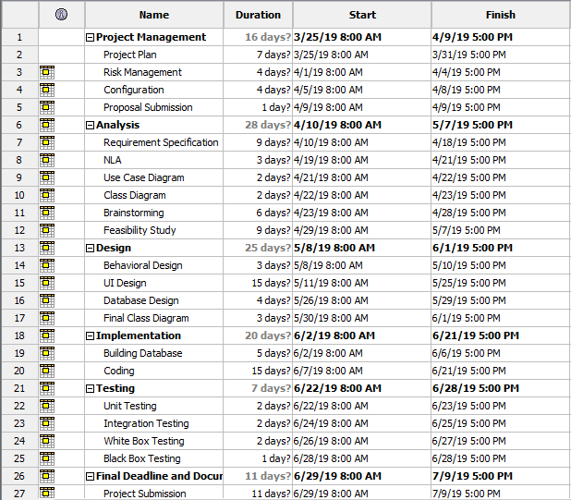

Figure 5: Time estimation table

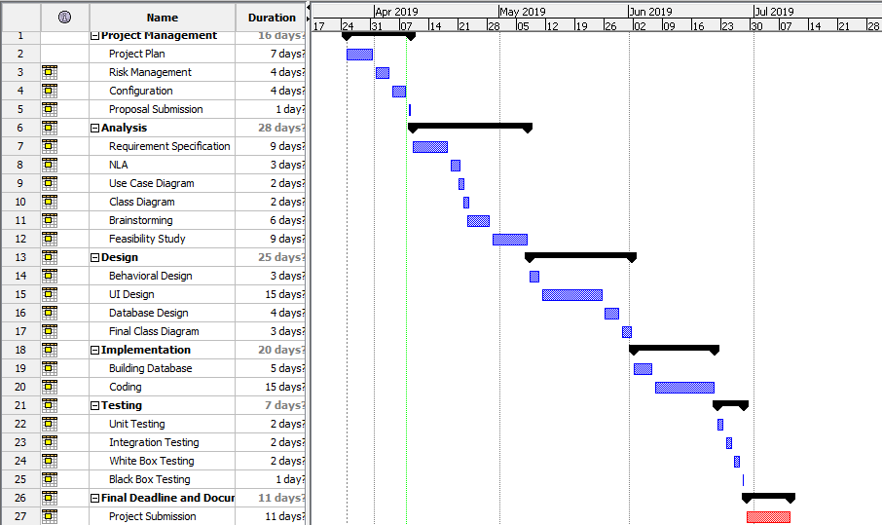

Figure 6: Gantt chart

# **Chapter 5: Risk Management**

Risk management is the process of identifying, assessing and controlling threats to an organization's capital and earnings. ***(techtarget, 2019)*** Risk management are done to verify and to analyze the risk that are seen on the future and to deal with it in the proper way. In this project also there might be some of the risk factor that must be analyze by me to outcome the best project.

For my project there might be many risks, so to deal with it I should find out the impact of the risk. And impact are found out by looking at the combination of likelihood and consequences.

Steps for risk management:

* **Risk identification**

In this step risks are discussed and following are the risk that I found:

* + Natural disaster
  + Hardware or software crash.
  + System may get infected with virus
  + Insufficient time
  + Requirements may not be found easily

* **Analyze the risk**

In this step likelihood and consequences of risks are determined.

* **Find out the impact**

In this step impact are found by likelihood * consequences.

* **Find out the solutions of risk**

In this step actions are taken to minimize the risk.

|  |  |
| --- | --- |
| **Likelihood (L)** | **Value** |
| Low | 1 |
| Medium | 2 |
| High | 3 |

Table: Likelihood

|  |  |
| --- | --- |
| **Consequences (C )** | **Value** |
| Very Low | 1 |
| Low | 2 |
| Medium | 3 |
| High | 4 |
| Very High | 5 |

Table: Consequences

|  |  |  |  |  |  |
| --- | --- | --- | --- | --- | --- |
| SN | Risks | Likelihood | Consequence | Impact | Actions |
| 1 | Natural disaster | 1 | 5 | 5[1*5] | Backup plan |
| 2 | Hardware or software crash | 2 | 3 | 6[2*3] | Maintenance |
| 3 | System may get infected with virus | 2 | 4 | 8[2*4] | Antivirus Software |
| 4 | Theft | 3 | 2 | 6[3*2] | Backup |
| 5 | Insufficient time | 3 | 3 | 9[3*3] | Must keep milestone on mind |
| 6 | Requirements may not be found easily | 3 | 1 | 3[3*1] | Should take an example of similar type of web application |

Table: Risk management analysis

# **Chapter 6: Configuration Management**

Project's Configuration is the some of total is its products or assets including management product. ***(configuration-management, 2002)***

This management is closely link with the quality and the change control. The main advantages of Configuration management is to help in reliability, cost reduction and the massive risk.

Below is the files name that I have uploaded in GitHub:

(Link: <https://github.com/NimeshPdl/New-CP-project> )

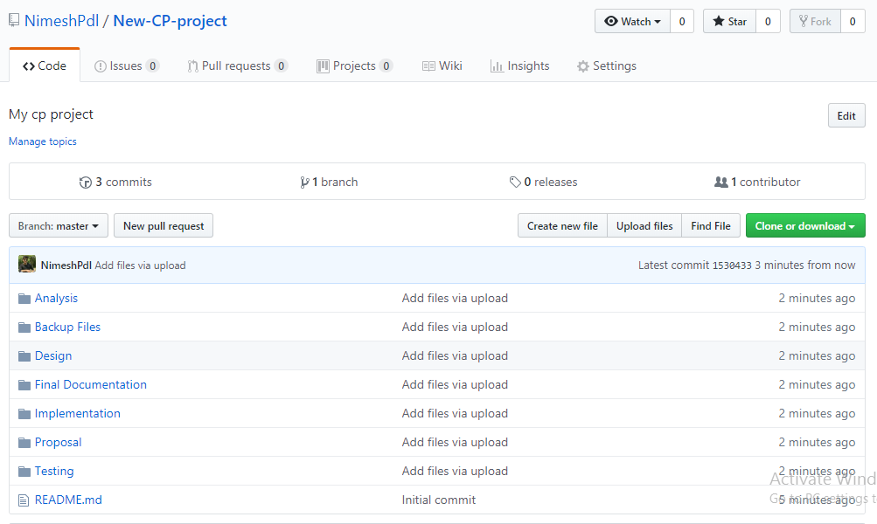

Figure 7: Showing the uploaded files in GitHub

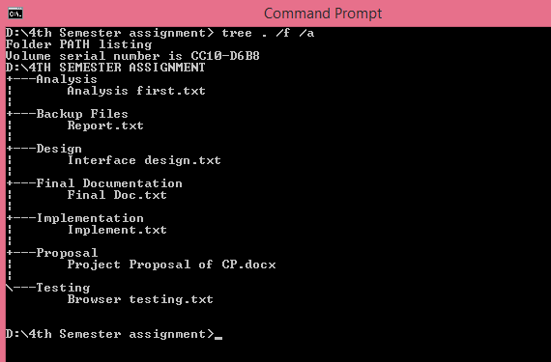

Figure 8: Folder Tree Structure

# 2. Analysis

## 2.1 Introduction

Analysis is the process of collecting and gathering information and its operation for the betterment of the system. Analysis is the 1st process of software development process. If the analysis is in the good way then better software is developed. Analysis is done for fulfilling the requirement of the customer or the developer. If analysis is not done then we are unable to get the software that we imagine or we are willing.   
  
Analysis of requirements is an iterative procedure that starts with a brainstorming meeting and continues through the course of development. ***(FRANCIS, 2014)***

Requirement analysis is also done with the group discussion, interviews, focus groups, etc. Requirement analysis contain all the tasks that are need for the stakeholders. High quality of requirements are documented, actionable, measureable and traceable.

As I am going to develop the website so I hardly need the analysis for the betterment and development of my website.

**SWOT analysis for my project:**

I have choose this type of analysis for my project because it helps me to find out the strength and weakness of my project. This analysis also helps me to create an opportunities in the future, and also give me an idea about the threat that may arise in the future.

For checking the strength, we must deal with the questions that what benefits this project gives to user? And also why it is better than any other software? If we get this answer than we will know our strength.

For the weakness, we must look after the things that we must avoid so that in future the project will not be weaken. Also we must be able to look after the factors that we must look after to improve our project.

And to find out the opportunities from the SWOT is by looking after the strength and finding out what opportunities that a project can give in the future.

And the threats are find out through help of SWOT by the obstacles that we are facing in the current context. Also thinking about the competitors.

So, by the help of SWOT analysis, I can clearly avoid the future issue and can complete my project with ease.

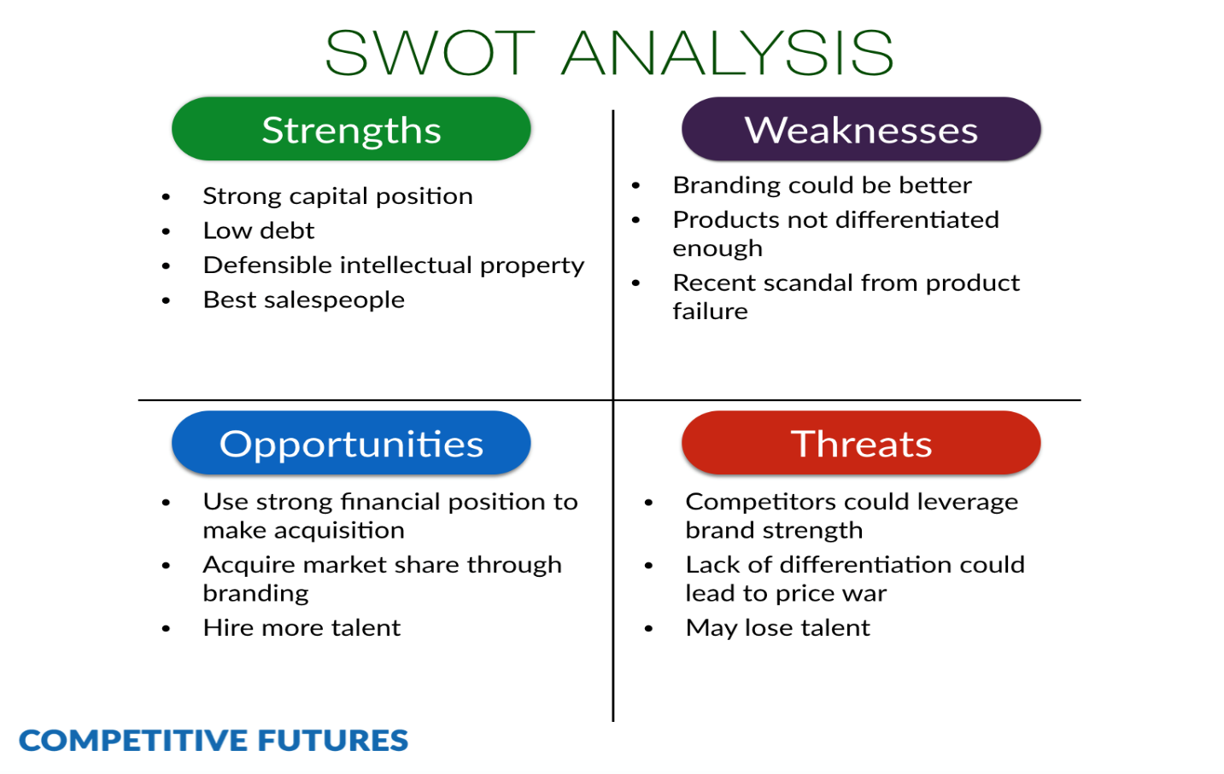

Fig: SWOT analysis

## 2.2 Feasibility Study

Feasibility study is an analysis that notices all the significant factors that are used to develop the software. In this feasibility study, it includes the economical study, technical study, legal study and many more. Developers use the feasibility study to develop the software with ease.

Similarly for my perspective, I must also look after the feasibility study to see the problems that may arises in the future and to tackle with them. Also with the help of this my software will be developed in such a way that it lasts longer.

For my project I must study the feasibility of my software. To do that here are some of the types:

1. Economic feasibility:

In this type of feasibility we must look after our fund or budget. If the software can be developed with the budget we have then it is economic feasible.

For My project, I don't need the budget to develop the software because it is a academic project and I won't need to travel anywhere to get the information. So my budget will not be used.

1. Technical feasibility:

This feasibility study will help us to know that whether or software and hardware are feasible to develop our software or not.

For my project, I don't think that hardware and software should be advanced, so technical terms are fulfilled for my project.

1. Legal Feasibility:

In this feasibility study we see that our projects meets the legal and the ethical procedure or not. If its meets than our feasibility study is complete.

For my project, legal feasibility is stable and good. Because as my project is based on the web application which is for the readers so there is not illegal to develop.

1. Schedule feasibility:

In this feasibility test we look after the time which we take to develop the project.

For my project, time is very much enough to complete my project. So I think schedule feasibility is also passed.

1. Operational feasibility:

In this feasibility test, we look after the user interaction. Whether our project is interact able to the users who uses it or not.

So as my project is simple to use than I think it is also operational feasible.

## 2.3 Requirement analysis

In this type of analysis we look after the functional and non functional analysis. In the functional requirement, we take one of the function from our project and analyze it. Similarly for non-functional requirement we do it same.

**Functional Requirement:** It is the procedure which helps us to know what a system do.

Functional requirements of my project are:

|  |  |  |  |  |  |
| --- | --- | --- | --- | --- | --- |
| **Functional ID** | **Functions in my project** | **Data** | **Rational** | **Dependency** | **Remarks** |
| F01 | Registration | Name and Address | Different names of the users | F01 | Add new readers |
| F02 | Login | Email and Password | Gives security to the readers or users | F01 | Help to order the books |
| F03 | Reset Password | Email | Password can be changed | F02 | New password is made for securing the profile. |
| F04 | Post notice of new coming books | Book name. | For the readers | F02 | Upcoming books are listed |
| F05 | Update Book | Post book details | For the Readers | F02 | Readers can easily see the book details that is updated |
| F06 | Admin Login | Admin details  ( Email and Password) | Admin | F06 | Open the dashboard of the admin |
| F07 | Update admin login (Profile) | Update the admin details | Admin | F06 | Details of the admin will be Updated |
| F08 | Asking Questions related books | Details | Readers to the admin | F02 | Readers can interact with the admin related book |
| F09 | Answer the Questions | Question Details | Admin to readers | F02 | Admin will answer the asked question |

Table: Functional Requirements

**Non Functional Requirements:**

Non functional requirements are those requirements which is not directly related but indirectly related to the project. It includes the quality attributes of the project.

Non-Functional requirements are of two categories. I.e. Execution and Evolution qualities. Execution is the observable during the run time while Evolution is the static structure of the system.

Table of non-functional requirements of my project are:

|  |  |  |  |  |  |
| --- | --- | --- | --- | --- | --- |
| **Non-Functional Id** | **Functions** | **Data** | **Rational** | **Dependency** | **Remarks** |
| N01 | Responsive | - | Support Different types of Resolutions | - | Fit in different screen sizes. |
| N02 | Usability | - | User friendly | - | User friendly |
| N03 | Reliable | - | Is trusted | - | People can easily trust the website |
| N04 | Robust | - | Supports many platforms | - | Should work with different platforms |
| N05 | Multi-Browser support | - | Tested in many browsers | - | Runs in different browser |
| N06 | Scalability | - | To be able to handle workloads | - | It will handle the data flow easily |

Table: Non-Functional Requirements

**MoSCoW Prioritization:**

MoSCoW prioritization is the technique for helping to understand and to manage the priority. ***(moscow-prioritisation, 2019)***

MoSCoW Prioritization for the Functional Requirements are:

|  |  |  |
| --- | --- | --- |
| **ID** | **Functionalities** | **Priority** |
| F01 | Registration | Must have |
| F02 | Login | Must have |
| F03 | Reset Password | Must have |
| F04 | Post Notice of Upcoming book | should have |
| F05 | Update Books | Should have |
| F06 | Asking Questions related books | Would have |
| F07 | Answer the Questions related books | Would have |
| F08 | Admin Login | Must have |
| F09 | Admin Profile Update | Should have |

Table:MoSCoW Prioritization for the Functional Requirements

MoSCoW Prioritization for the Non-Functional Requirements are:

|  |  |  |
| --- | --- | --- |
| **ID** | **Functionalities** | **Priority** |
| N01 | Responsive | Must have |
| N02 | Usability | Must have |
| N03 | Reliable | Should have |
| N04 | Robust | Must have |
| N05 | Multi-Browser support | Must have |
| N06 | Scalability | Won't have |

Table:MoSCoW Prioritization for the Non-Functional Requirements

## 2.4 Use Case Diagram

Use case diagram is the diagrammatic representation of the interaction between the elements of the system. It looks like flow chart but gives the proper idea about the system. It speaks about which actor is doing what.

As looking at my project, there are 2 actors. One the customer own selves and second one is admin who handle the website.

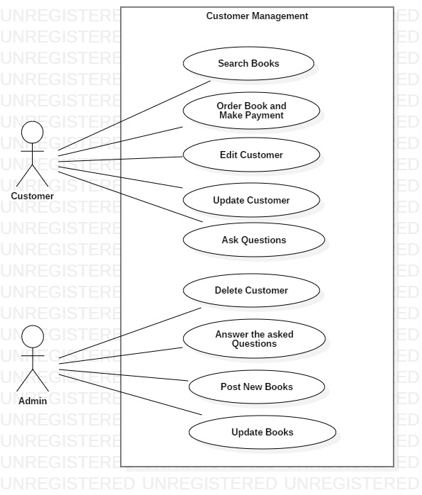

Fig: Use Case Diagram

## 2.4 NLA with Initial Class diagram

**Introduction:**

For my college project I have decided to develop a web application which help the people to buy or order a novels from online. My website also contains some of the various features. As my website is based on the online book management system but the book available is only of literature. Different categories of the books are available.

My website helps user or the readers to search the book according to their interest. My website helps the use to comment or give review about the books in the online forum. The review and comments written by users/readers is answered by the admin. Also my website contains the registration system in which user can register and can be easily connected to the website. In the review or the comment section or review section user can delete, update and insert their review. Also the User details which they have entered while registering themselves can be easily edit, delete and update.

Here are my candidate class list:

By looking at the above scenario I have divided into the nouns and verbs. Where nouns indicate the class and verbs indicate the methods.

Nouns:

1. College
2. Novels
3. Books
4. Categories
5. Readers
6. Users
7. Review
8. Comment
9. Register
10. Admin
11. Order

Verbs:

1. Buy
2. Search
3. Add, edit and delete the review
4. Add, edit and delete the user details
5. Admin replying the reviews and comments

Here are My Final Classes for initial class diagram:

1. Book
2. Categories
3. User
4. Review
5. Order

Proper Reason about I selected these classes for my initial class diagram are:

|  |  |
| --- | --- |
| **Book** | I select this as class because users order the books of different categories from the website. Also in between the novels and the books, I select it because it seems more standard. |
| **Categories** | I select this as class because it indicates the types of books. |
| **User** | Without the user, engagement in the website will not be possible. And I select the User rather than the readers because user indicate all the peoples involved in the website. |
| **Review** | I selected review because here are the views of the users' related books. Also I select it rather than comments because it seems more advanced and is standard word. |
| **Order** | I select the order because user will buy the books from the website by online. And selecting it rather than the buy is due to the word weight. |
| **Register** | I select this because the people who registers will be added to the database and can order the books. |

Here is my Initial Class diagram:

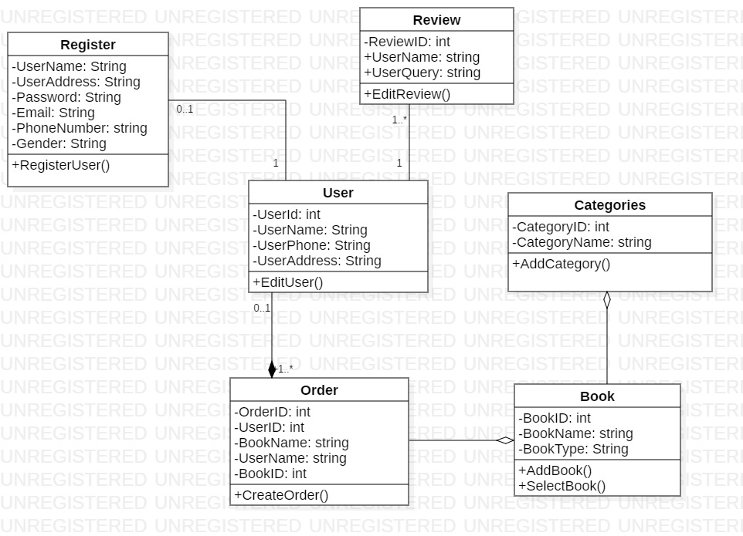

Fig: Initial Class Diagram

**3. Design**

**3.1 Introduction:**

Design is the process of creating something on the basis of some perspectives. Generally design is done looking at the user perspective and needs. Design is different by looking at the things you are developing and requirements. Design is very necessary in any development. It is the 1st impression of any sort of program or application.

Benefits of designing:

* It sets the impression towards the customers or users.
* Sometimes a good design may provide a trust from user/customers.
* Its helps user to use the application with ease.

**3.2 Structural design**

Structural design is the method of investigating the strength, stability and rigidity. Generally we do it for looking the structural view of the system. Structural design also supports the architectural design.

Class diagram, Data flow diagram and flowchart are some examples of structural design.

For my project, I have made class diagram to find out the structure of my project.

1. **Class diagram:**

Class diagram is the static diagram which also represent the static view of the project. For my project I have made the class diagram to see the static view and how it will work. Class diagram also helps to analyze and design the static view of the application.

**Justification of my class diagram:**

I have made the class diagram by considering the future stability. After the register is done user can easily order the books with the categories they like. Also user can give the review of the books.

**Notation uses:**

*Aggregation notation:* This notation is used to configure the objects for making the complex type of object.

*Composition notation:* This notation is used for the composite objects.

*Association notation:* This type of notation is used to inter-relate the class.

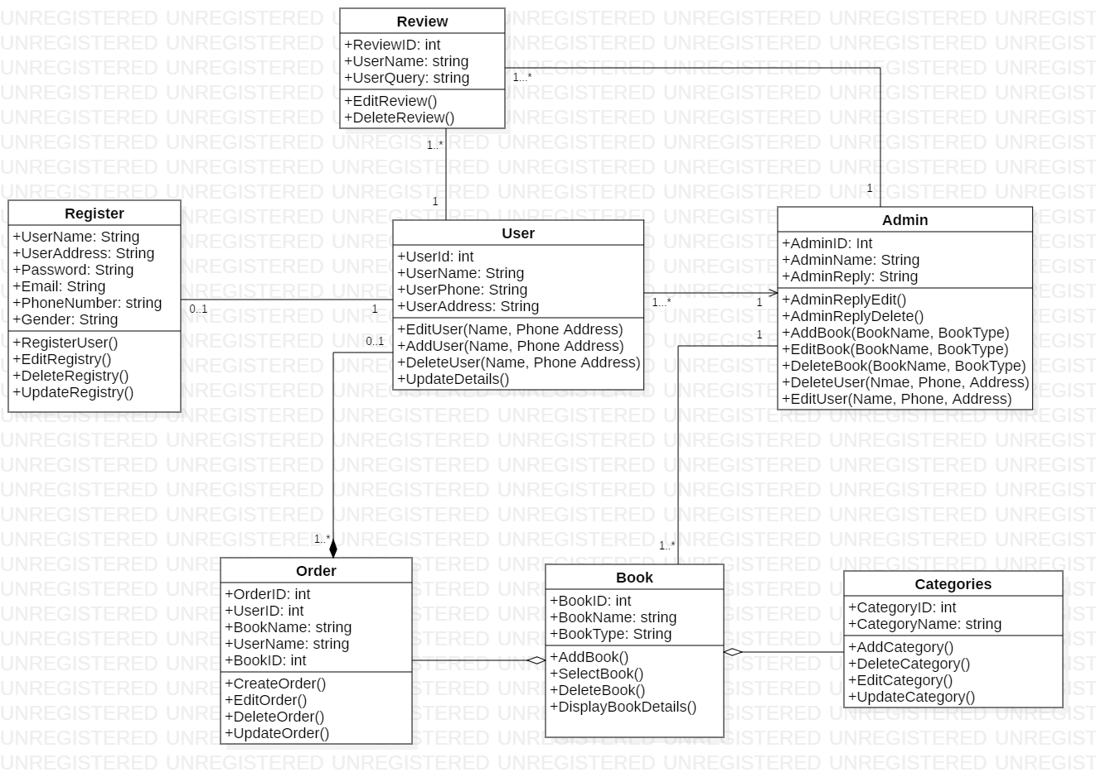

Fig: Final Class diagram

**Explanation:**

My class diagram consists of 6 classes which is very important for developing the project. First of all, use will register themselves with the name, address and contact number. After the registering they can order the books with different categories of their interest. After registering themselves, they can also review the books, after they read it.

1. **DFD:**

DFD is the type of structural design. DFD is the known as the Data Flow Diagram. This diagram shows the flow of the data or process. Data Flow Diagram also provide the information about the outputs.

For my project too, I have made the data flow diagram to analyze the flow of my information. This diagram will give the enough knowledge to others about how the data will flow.

**Justification:**

Data flow diagrams are used to graphically represent the flow of data in a business information system***. (data-flow-diagram, 2019)***

DFD is very essential to my project because it shows the path of the program and how it will be working after the program is made.

**Notation used:**

*Process Notation:* This notation helps to transfer the incoming data flow into the out going data flow.

*Data stores Notation:* This notation are the repositories of the system.

*Data flow notation:* This notation helps to find the flow of data in what direction.

*External entity notations:* This notation gives a clue about the objects outside of the system.

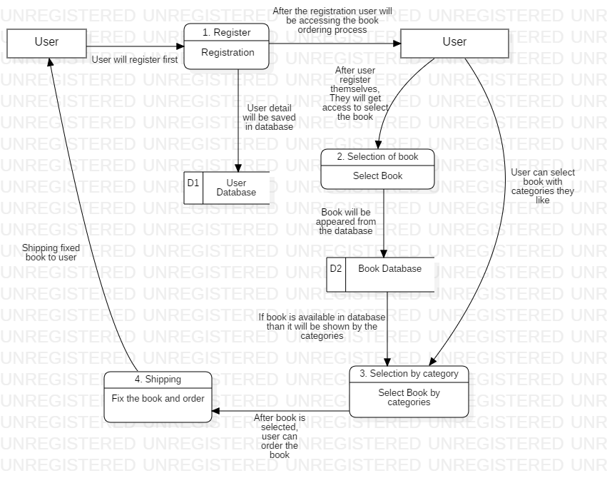

Fig: Data Flow Diagram

**Explanation:**

In this data flow diagram, User is the initial entity. User will be registering themselves before selecting the book. After the user will be registered, data will be saved in the database of the users. After the user data will be on the database, user can select the book. User can also select the book with the categories. The categories of the book will be appear from the book database. After the book will be selected by the user of their interest than book will be ordered than will be shipped to the user.

**3.3 Behavioral Design**

Behavioral design is that type of design which help to communicate between the two objects. This design create the flexibility between the objects.

Behavioral design also helps to find out how the system works and does the work. Behavioral design examples are: Activity diagram and sequence diagram.

1. **Activity Diagram:**

Activity diagram are those type of diagram which show the dynamic aspects of the system. Activity diagram is basically a flowchart to represent the flow from one activity to another activity. ***(uml_activity_diagram, 2019)***

Activity diagram generally describes the operation of the system. The Control flow is generally drawn from the one operation to another operation of the system.

For my project too, I have made the activity diagram. In my activity diagram I have shown the flow of an operation which makes the system/ in a system.

**Justification:**

Activity diagram is made to see the dynamic aspects of the system. It means that, it is the systematic flow of process. With the help of this diagram, we can easily assume that what will happen in which step.

For my project too I have made the activity diagram. In that activity diagram, it clearly shows the step that will carry out to complete my project.

**Notation Used:**

*Start Point:* This is the point which represents the initial action state.

*Action State:* This point represents the non interruptible actions of the step.

*Action flow:* This notation helps to flow the object from one action state to another.

*Decision branching:* This notation helps to decide like if/else condition.

***Synchronization:***

*Fork node:* This notations help to split the one action state into two or many.

*Join node:* This notations helps to combine the two or many action state to one action state.

**Diagram:**

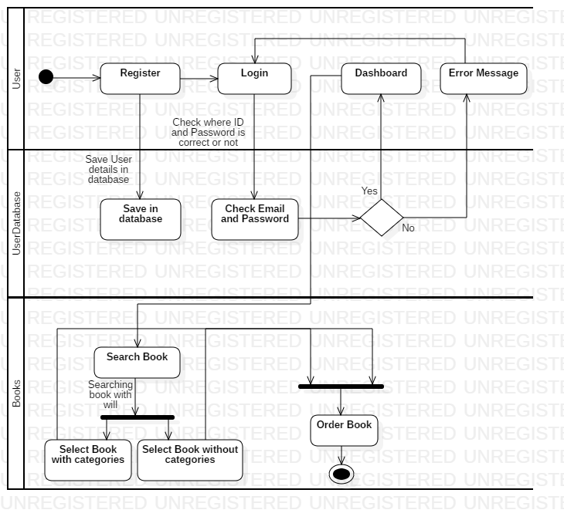

Fig: Activity Diagram

**Explanation:**

Explaining about the dynamic state of system is only possible with the help of activity diagram. So in this diagram, I have clearly described how my system will work. At first user will register themselves, after that they can login into the system. If password/email will be incorrect, they must start with login again. But, if the login is successfully done than user can easily search book and order for themselves.

1. **Sequence Diagram:**

Sequence diagram are the interaction between the diagrams which gives us detail about how the operation is carried out. Sequence diagram are generally the time focused and capture the interaction between the objects.

For my project too, I have a sequence diagram. With the help of this diagram, viewer can easily get the knowledge about the interaction between the object and how they deal with themselves.

**Justification:**

For my project I have made the sequence diagram to know the interaction between the objects. As sequence diagram show the flow of the data in sequence, I have made the flow of data of my project in sequence as shown in the figure.

**Notation Used:**

*Lifeline:* This notation helps to represent the all instance in every interaction.

*Message:* This notation help to send the text.

*Message reply:* This notation help to reply the text to the object.

*Self message:* This notation help to write the text to own self object.

*Actor:* This notation is for the object which is important for the system to run.

*Combine fragment:* This type of notation help to write down the if/else statement.

*Object:* This is the class like structure without which system flow isn't possible.

**Diagram:**

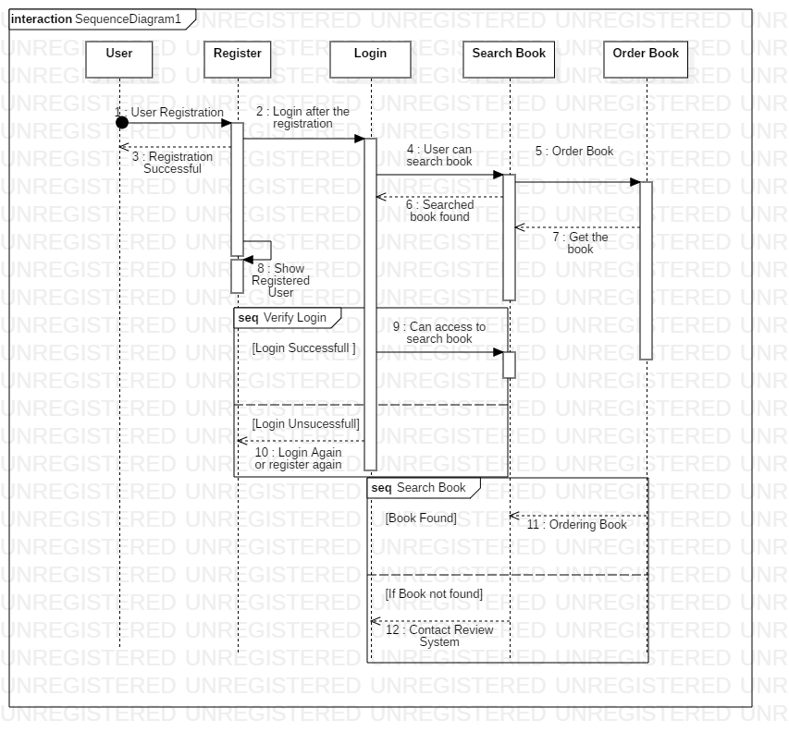

Fig: Sequence Diagram

**Explanation:**

In this sequence diagram, I have clearly shown the object that flow through the entire system. In this sequence diagram I have started with the actor and finished with the ordering the book. In this sequence diagram, I have also mentioned the word of combined fragment, which shows the if/else like statement. As the figure is Cristal and clear, anyone can know what will be happening in the system. Here in the above. There is no much work of Admin than to reply in the review system, so that it is not quite necessary to give admin the space in the figure above.

**3.4 Database Management System**

Database management system is the management software to manage the database. This system also help to create the database. This system creates the way to end-user to create, edit and delete the data.

There are more advantages of the DBMS:

* Data security and independence
* Robust data integrity
* Auditing of activity
* Simple access using API
* Data abstraction

1. **Data Dictionary:**

A data dictionary is a file or a set of files that contains a database's metadata. ***(data-dictionary, 2019)***

Data dictionary also contains the data of other objects. Such as data ownership, data relationships. Etc. Data dictionary is the crucial component of the relational database. Data dictionary generally contains of Name, type, length and many more.

**Justification:**

In my data-dictionary, I have taken 8 entities. All 8 entities do have the metadata. As data dictionary give the detail information about the Meta data, here is the data dictionary of my project.

**Data-Dictionary of entity Users:**

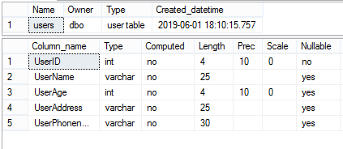

**Data-Dictionary of entity Order:**

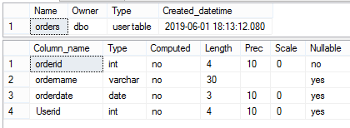

**Data-Dictionary of entity Order_Book:**

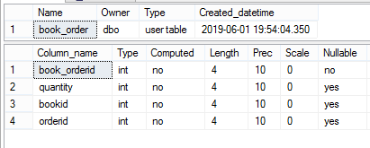

**Data-Dictionary of entity Book:**

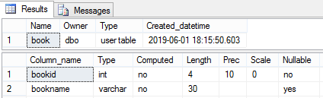

**Data-Dictionary of entity Author:**

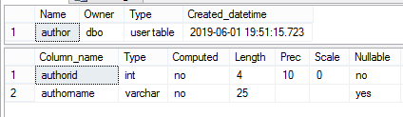

**Data-Dictionary of entity Author_book:**

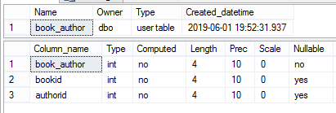

**Data-Dictionary of entity Review:**

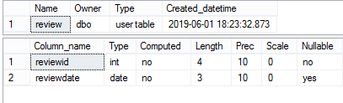

**Data-Dictionary of entity Payment:**

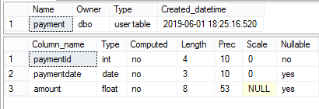

**Explanation:**

As explaining these data dictionary, all have a proper data with valuable length. Data dictionary clearly shows the datatype, length, null able or non-null able value, etc.

Due to the above figure, it clearly shows the data dictionary of my project.

1. **ER (Entity Relationship):**

ER is known as Entity relationship. ER diagram generally gives knowledge about the relation between the entities. They are also very important to modeling anything from simple to complex database.

**Justification:**

For my project, I have relate the 8 entities. In the 8 entities, I have given the column name which is proper to them.

Here are right Entities:

* Users
* Order
* Book
* Book_Order
* Author
* Book_author
* Review
* Payment

**Notation Used:**

*Fields:* This notation is used to classify the entity and their columns.

***Keys***

*Primary key:* This key uniquely identifies the column.

*Foreign key:* This key are created any time an attribute relates to another entity.

***Cardinality and Ordinality***

Cardinality and Ordinality are the notations that are used to relate the one instance of one entity to another instance of another entity.

In this types, I have used these 3 notations:

*One to many:* This notation helps to relate the one instance of one entity with the many instance of another entity.

*Many to many:* This notation helps to relate the maximum number of times an instance in one entity with other many instance of another entity.

**Diagram:**

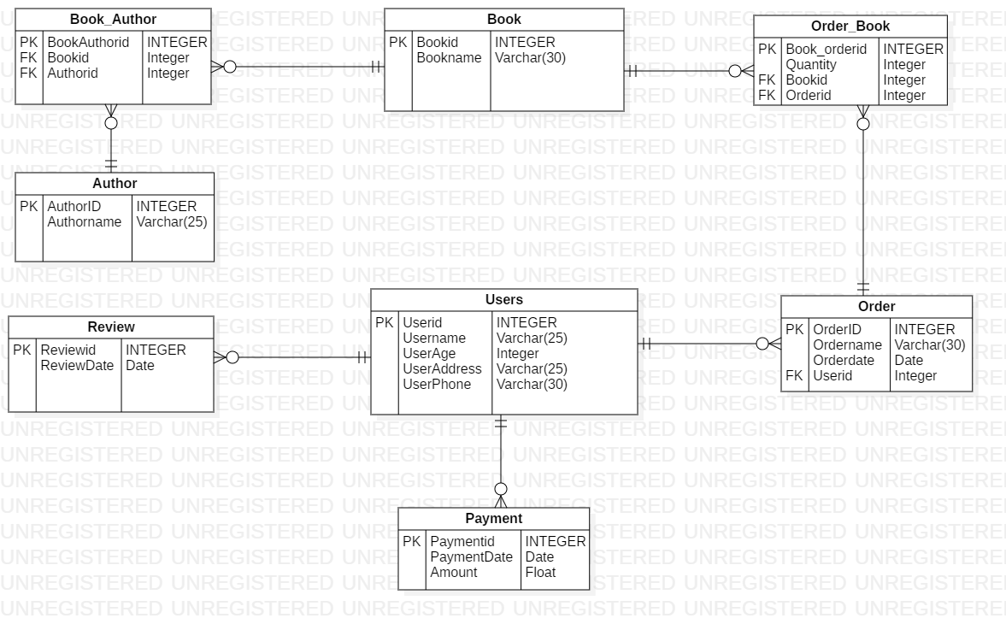

Fig: Entity relationship diagram

**Explanation:**

As I have created the entity relationship diagram, it gives the knowledge about the entity and how they act with each other. This entity relationship diagram also gives an idea about which entity is dependent with which entity.

**3.5 Architecture**

Architecture is the fundamental structure that must be made to give shape to the system. Architecture is generally called the blue print of the system. Architecture helps to design the system, edit it if necessary and proceed to develop the system.

I have used 3-tier architecture for my project.

A 3-tier architecture separates its tiers from each other based on the complexity of the users and how they use the data present in the database. ***(dbms_architecture, 2019)***

3-tier architecture is mostly used architecture in the DBMS.

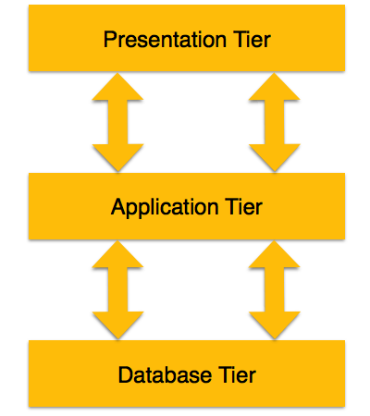

3-tier architecture works with the help of Presentation, Application and Database tier.

In the **presentation tier**, user operating will be carry on. They only know about the things that they see, they won't be access to the database.

In the **Application tier**, the connection between the application server and the database will be connected. For the user, this tier will show the abstracted version of the database.

In the **database tier**, all the data of the system will be stored. In this tier query processing language will also be stored.

**Justification:**

As completing the talk about the architecture, now I have made some of the paper prototyping which completely define my system. As paper prototyping must be clear, I have made the prototyping in the clear way.

**Here are the prototypes of my project:**

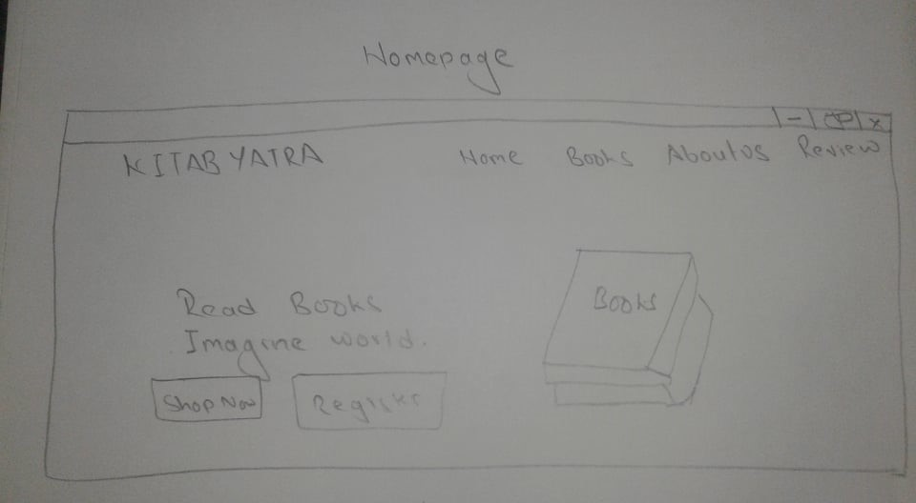

Fig: Homepage of Website

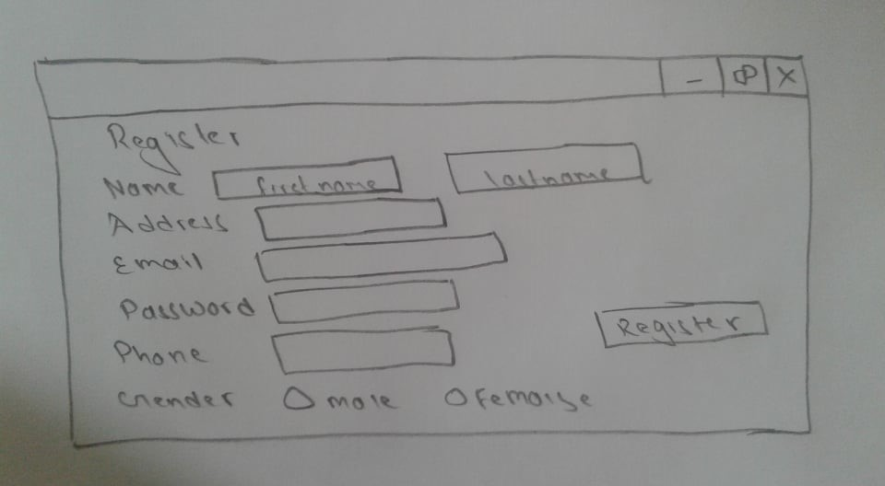

Fig: Registration Form

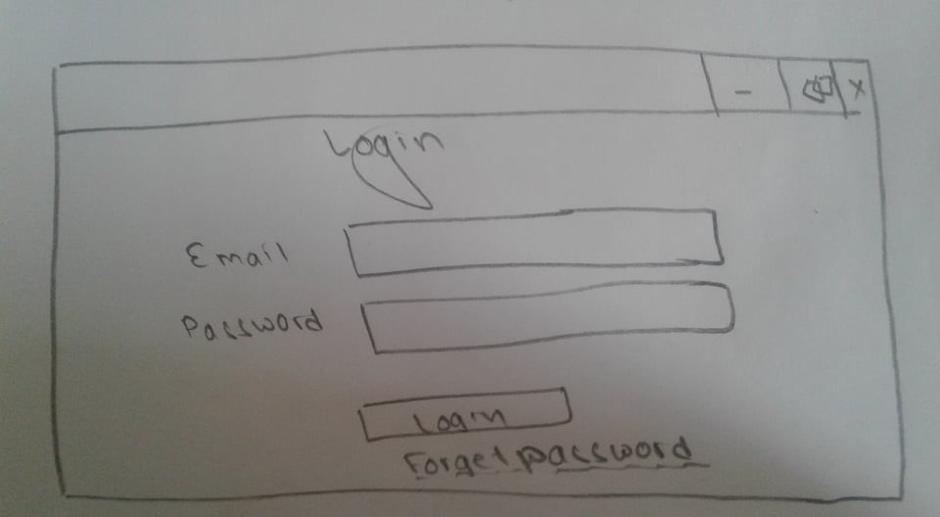

Fig: Login Form

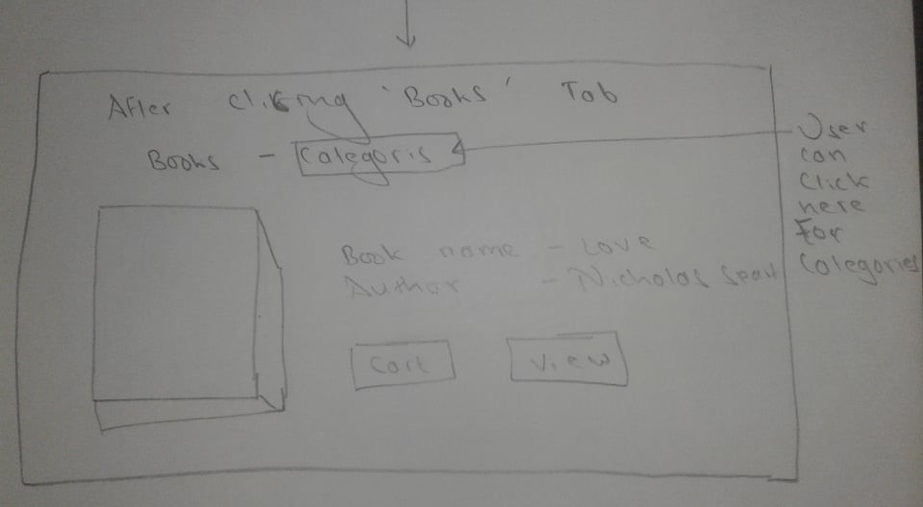

Fig: Books section of website

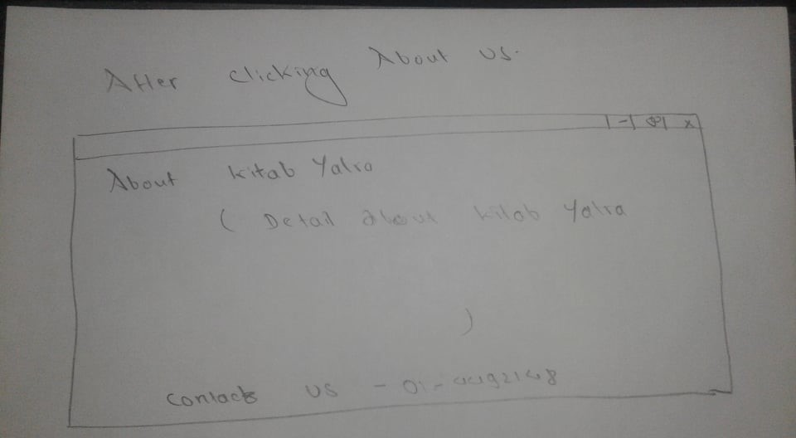

Fig: About Us Section of Website

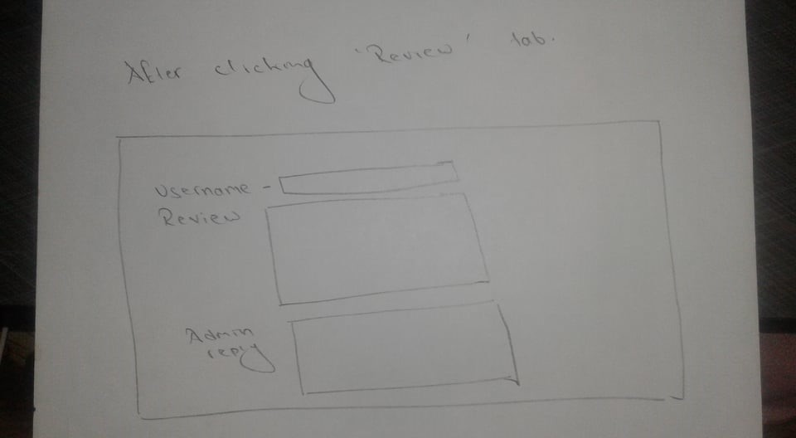

Fig: Review section of website

**Explanation:**

Above in the figure, I have made 4 prototypes of my project. Prototypes are only the blue print of the system and if the system require more feature than it will be edited and updated. As 4 prototypes looks in the figure above about how my website looks, it will be made in the same way.

**4.Testing**



Testing is define as the activity to check whether the expected result is matched with the actual result or not ***(software-testing-introduction-importance, 2019).*** Software testing generally helps to find out the errors of the program.

There are many types of testing. Some of them are:

1. Alpha testing
2. Regression testing
3. Acceptance testing
4. Black box testing
5. White box testing
6. Unit testing
7. Boundary value testing

But for my project I will only use the 2 type of testing, I.e. Black box and Unit testing.

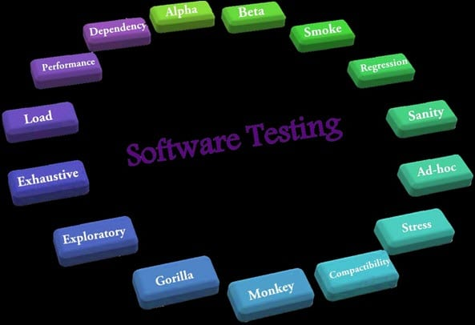

Fig 2: Types of testing

* 1. **Black Box testing:**

That type of testing in which the internal processing isn't seen but only the input and output is called black box testing. This type of testing is also called the behavioral and eye-to-eye testing.

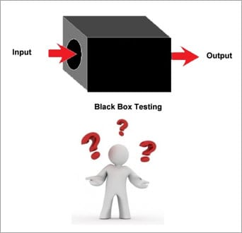

Fig 3: Black Box testing

* + 1. **Test plan:**

Test plan for black box testing is the document which describes and clarifies about the activities that has been tested. Test plan are of different types. Here is my test cases table of black-box:

|  |  |  |  |  |  |
| --- | --- | --- | --- | --- | --- |
| S.N | Test Case | Test Data | Expected | Actual Result | Date of testing |
| 1 | Registration without filling up the form | Registration Form | Mustn't be register | Register unsuccessful | 6/28 |
| 2 | Registration with filling up the form | Registration Form | Must be register | Register success | 6/28 |
| 3 | Testing phone column with more than 10 digits | Phone column | Mustn't be taken by system | Isn't taken | 6/28 |
| 4 | Testing phone column with exact 10 digits | Phone column | Must be taken by system | Is taken | 6/28 |
| 5 | logging in without password | Password | Mustn't be log in | Isn't log in | 6/28 |
| 6 | logging in with password | Password | Must be login | Login success | 6/28 |
| 7 | Without the correct email | Email | Mustn't be login | Isn't logged in | 6/28 |
| 8 | With correct email | Email | Must be login | Login successful | 6/28 |
| 9 | Logging in with invalid password | Password | Mustn't be login | Login unsuccessful | 6/29 |
| 10 | Logging in with valid password | Password | Must be login | Login successful | 6/29 |
| 11 | Ordering book without filling up the form | Order Form | Mustn't be order | Ordering wasn't success | 6/29 |
| 12 | Ordering book with filling up the form | Order Form | Must be order | Order Success | 6/29 |
| 13 | Book adding by admin without filling the description in form | Admin panel of Posting books | Mustn't be added | Isn't added | 6/29 |
| 14 | Book adding by admin with filling the description in form | Admin panel of Posting books | Must be added | Book is added | 6/29 |
| 15 | Sending message without filling Newsletter form | Newsletter Form | Message Mustn't be sent | Isn't sent | 6/30 |
| 16 | Sending message without filling Newsletter form | Newsletter Form | Message must be sent | Is sent | 6/30 |
| 17 | Without login user can't delete own selves | User Profile | Mustn't be deleted | Isn't deleted | 6/30 |
| 18 | Without login user can't delete own selves | User Profile | Must be deleted | User is deleted | 6/30 |
| 19 | Deleted user can't log in | Login Form | Mustn't be login | Login wasn't success | 7/1 |
| 20 | After Login Chat/Review form appears | Review Form | Must appear | Review form appeared | 7/1 |

Table 1: Test case Table for Black-box

Here are my all black box testing:

1. Registration form testing with all form filling:

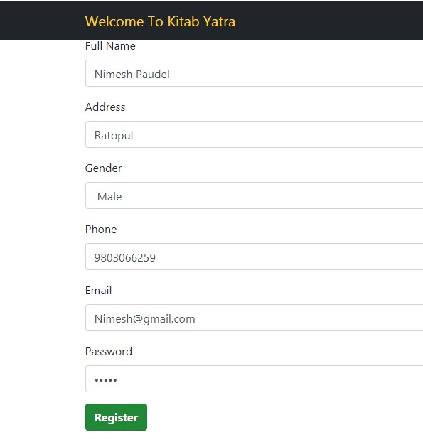

***Fig 4: Registration Form***

After I clicked on registration, User is registered and Login form is shown.

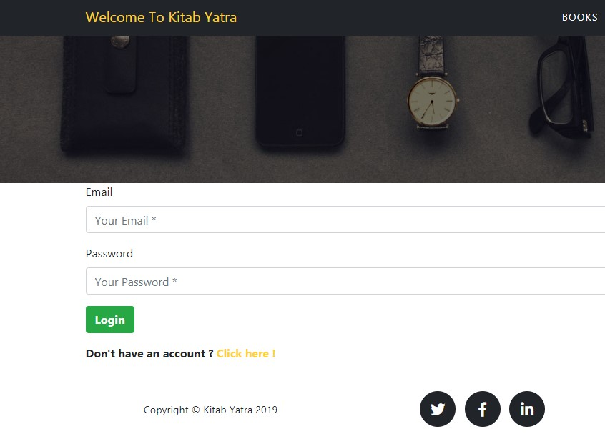

***Fig 5: Login Form***

1. Testing registration form without filling up the form:

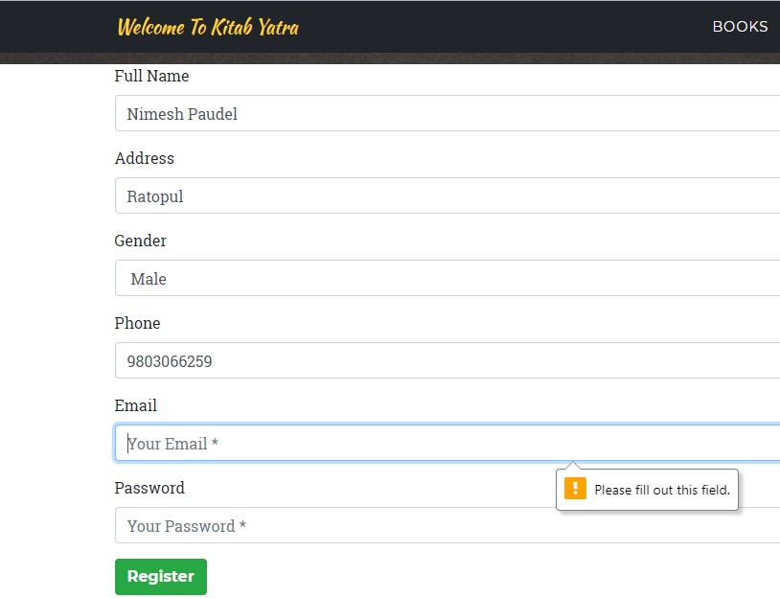

***Fig 6: Registration Form***

1. Testing Phone column with more than 10 digits or less than that:

For the phone number, I have assigned the numeric digits of exact ten. Phone column will give the error message till the phone number will not be exact of length 10. More than 10 or less than 10 will cost the error message.

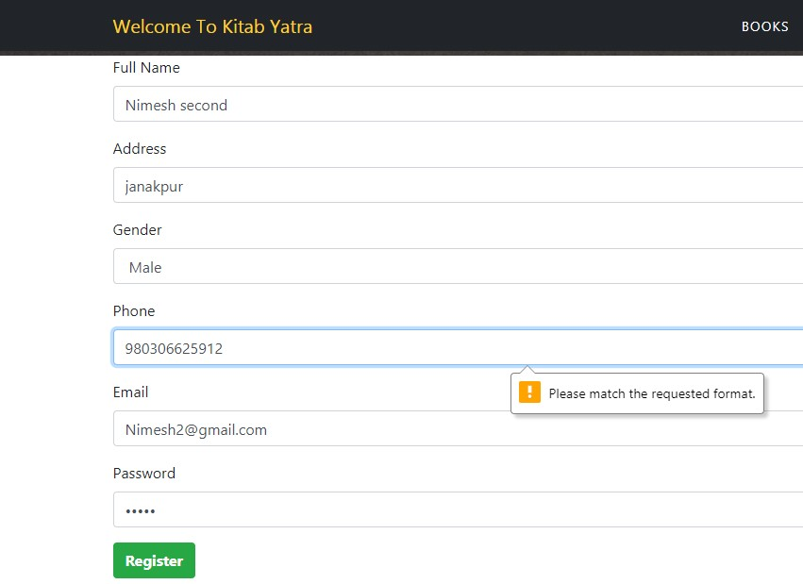

***Fig 7: Registration form for testing Phone column***

4. Testing Phone column with exact 10 digits:

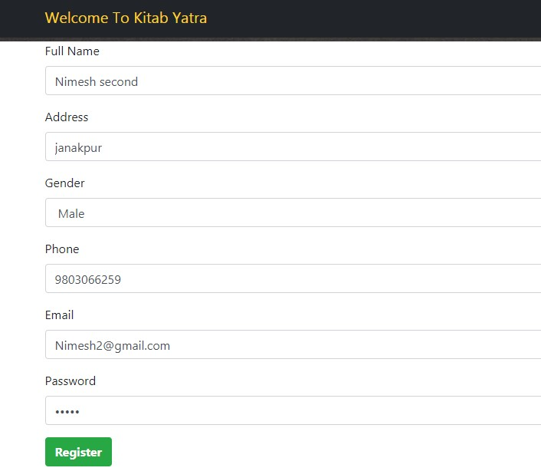

***Fig 8: Testing phone column***

5. Testing Login Form without password

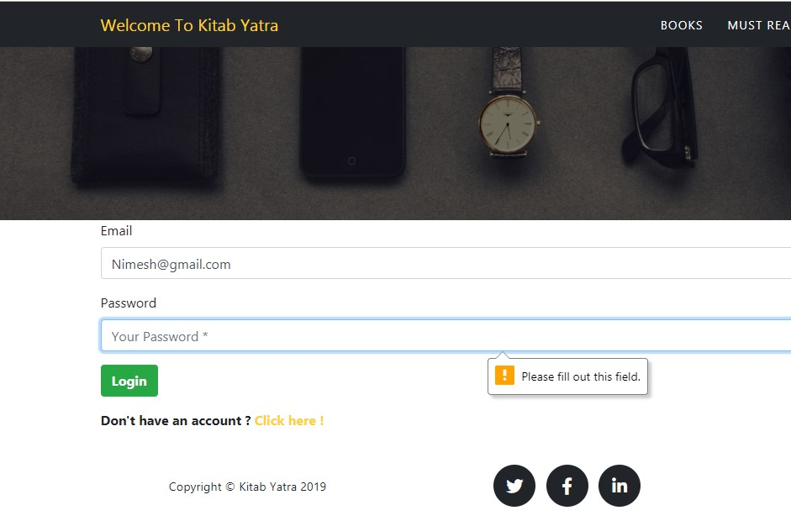

***Fig 9: Login form without password***

6. Testing with Password:

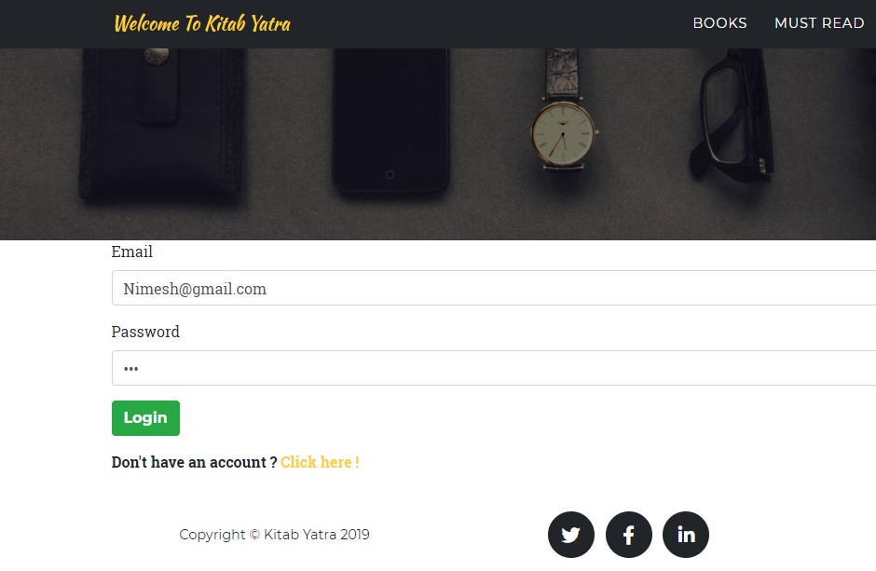

***Fig 10: Login with password***



***Fig 11: Login successful***

7. Login testing with Invalid password

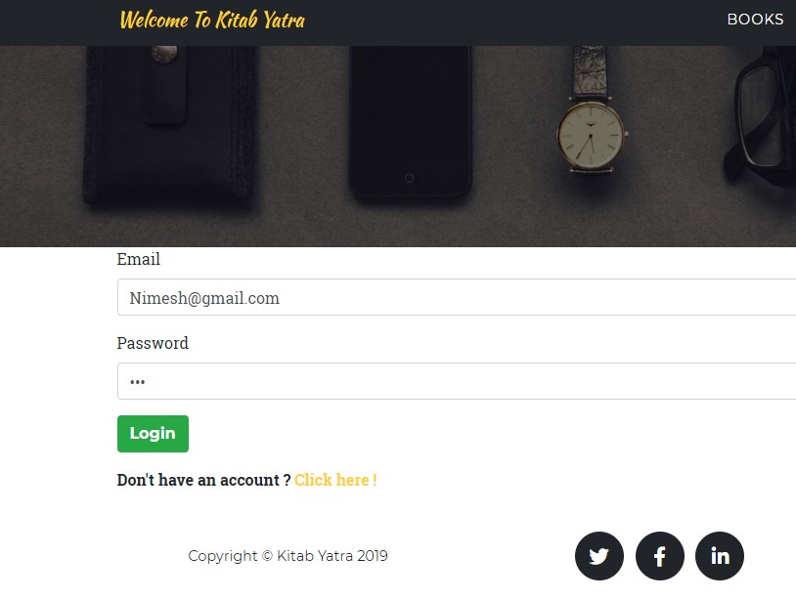

***Fig 12: Invalid Password for login***

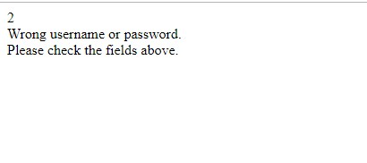

***Fig 13: Error message of login***

8. Login Testing with correct password

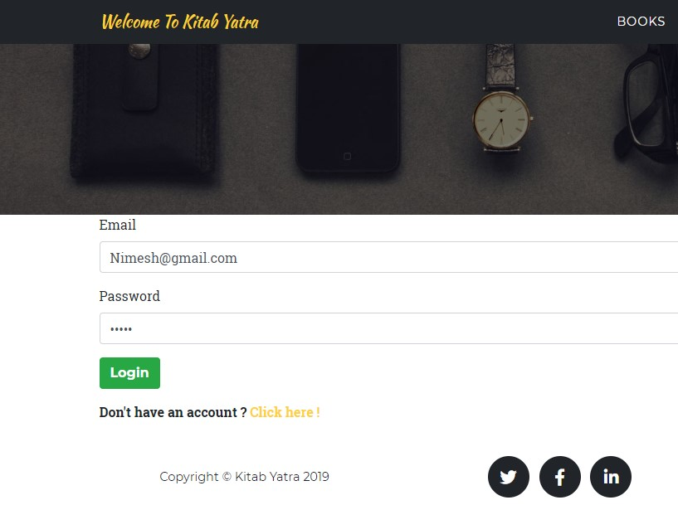

***Fig 14: Login form with correct password***



***Fig 15: Index appears after login success***

9. Login with invalid email

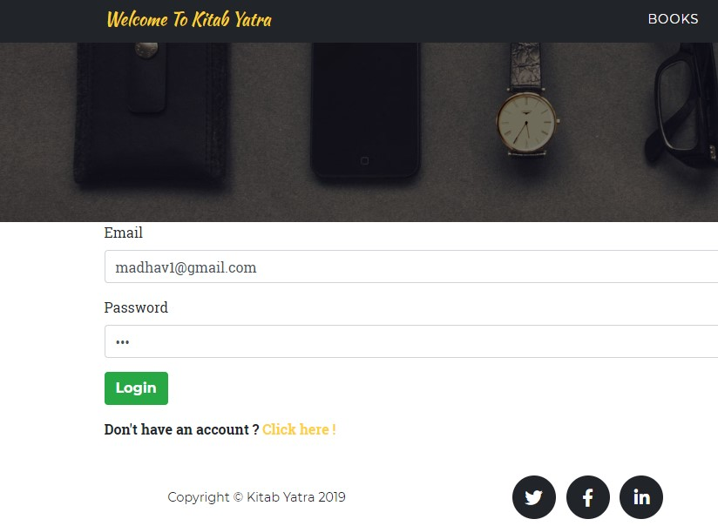

***Fig 16: Login with invalid email***



***Fig 17: Same invalid message appears***

10. Login with correct email

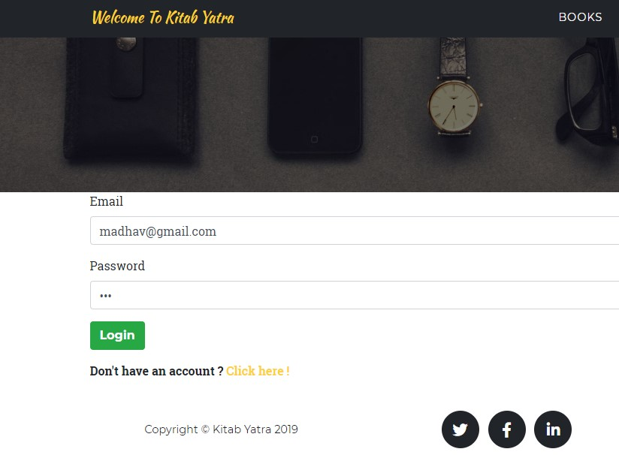

***Fig 18: Login with correct email***



***Fig 19: Index appears***

11. Ordering book without filling up all the form

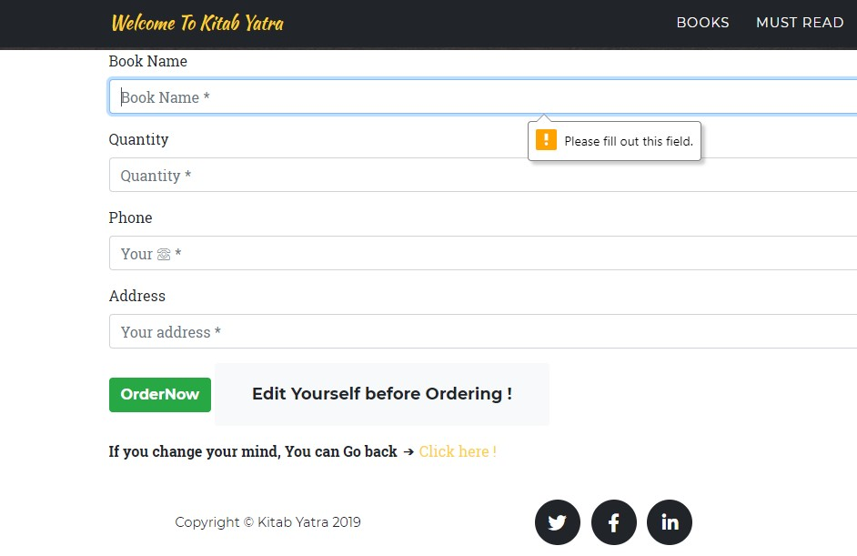

***Fig 20: Order form***

12. Ordering form with filling up the form

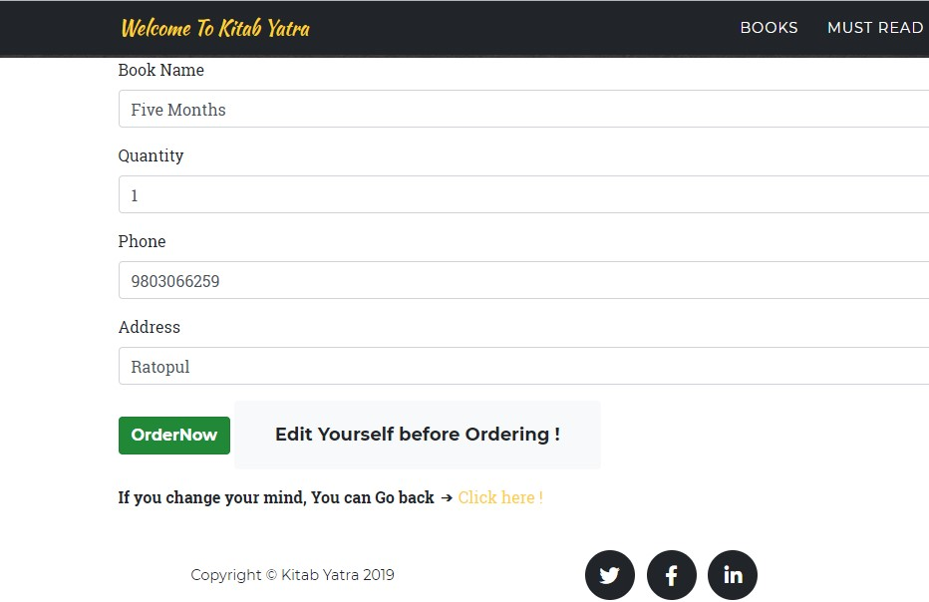

***Fig 21: Filling up the order form***

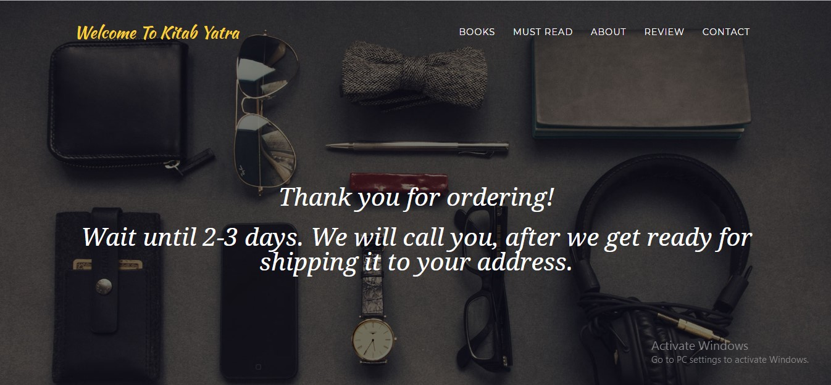

***Fig 22: After filling up the form and ordering this message appears***

13. Adding book by admin without filling up the form

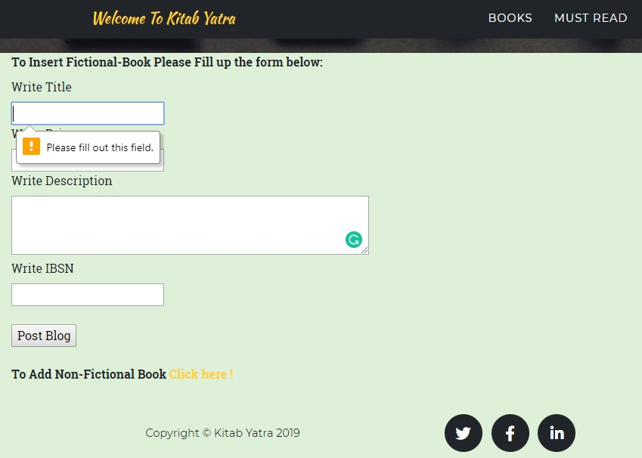

***Fig 23: Admin panel for adding books***

14. Adding book by admin with filling up the form

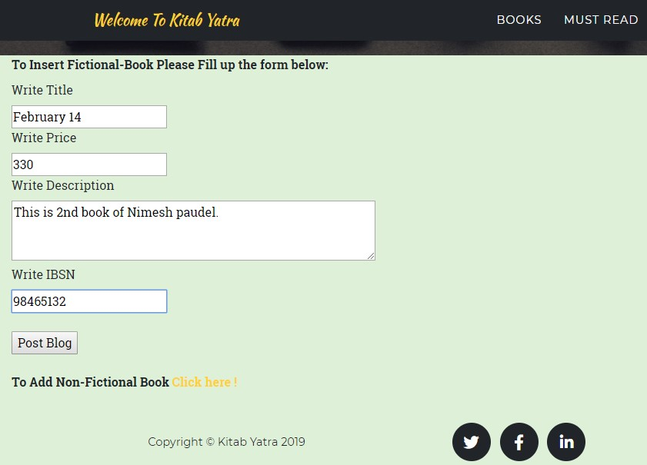

***Fig 24: Filling up form for adding book***

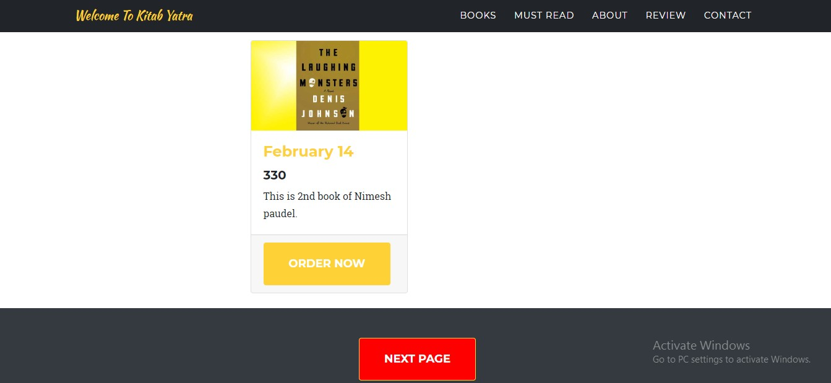

***Fig 25: Book added***

15. Message isn't send unless form is filled for newsletter

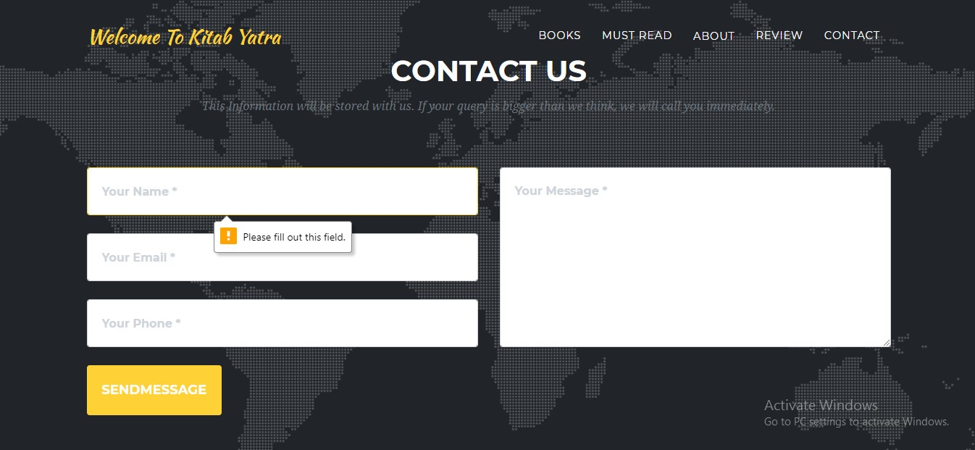

***Fig 26: Newsletter form***

16. Message is sent after the newsletter is filled

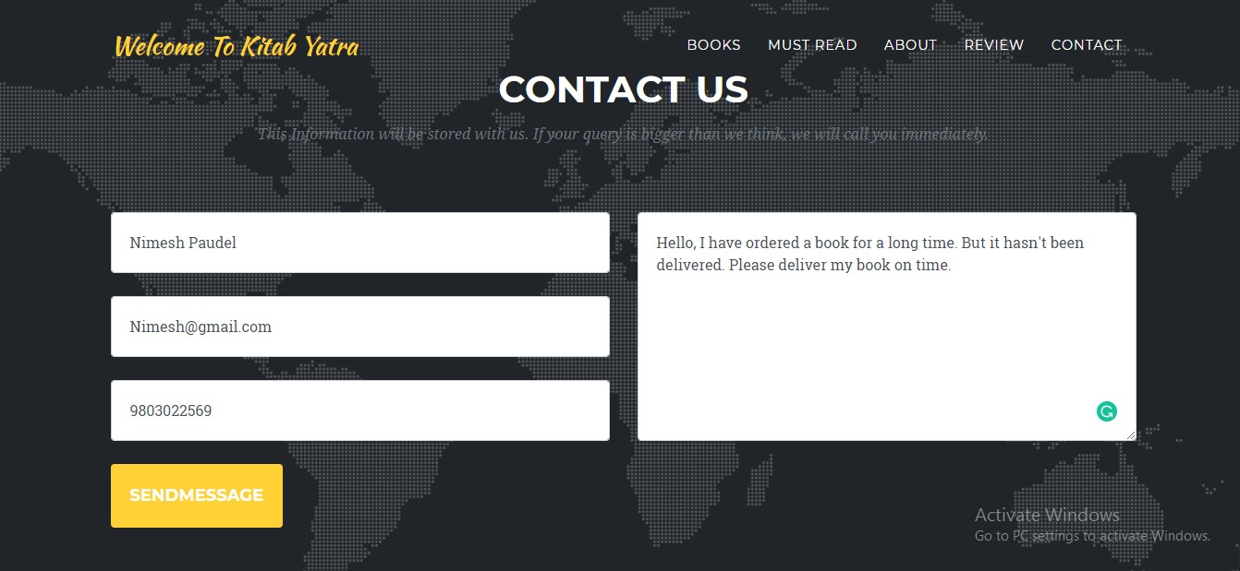

***Fig 27: Newsletter Filled***



***Fig 28: Index appeared after the message is sent***

17. Without login review/chatting with other users isn't possible



***Fig 29: Without login clicking the review will not appear***

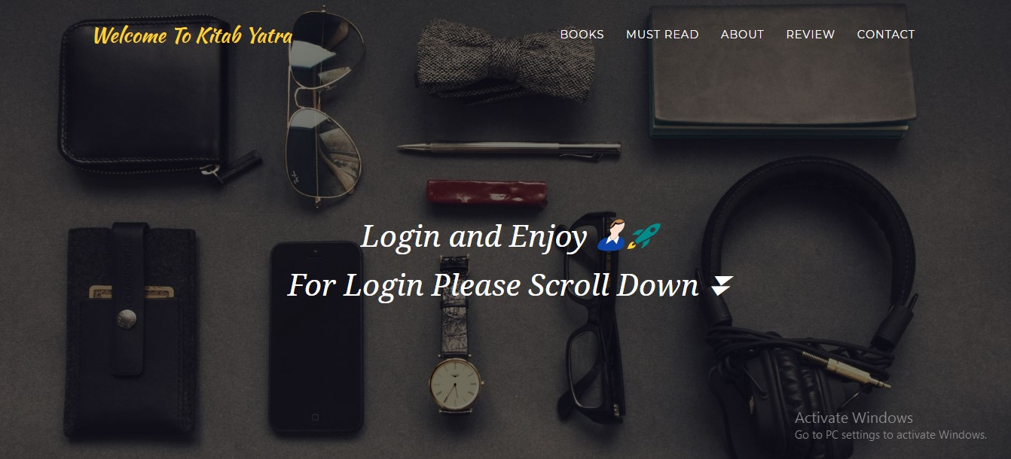

***Fig 30: After user click on review login form will appear***

18. After the login review/chatting section appears

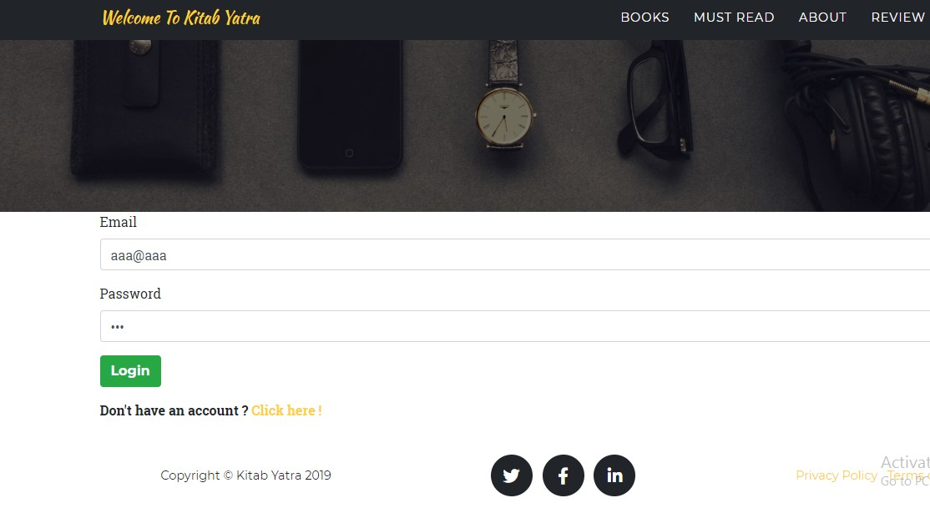

***Fig 31: Login with correct email and password***

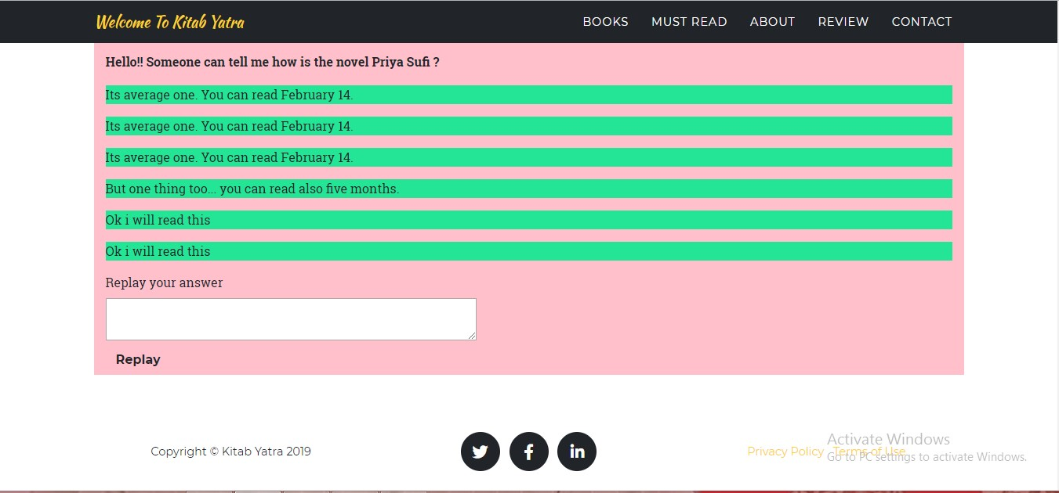

***Fig 32: Review section appears after login***

19. Delete user by own selves

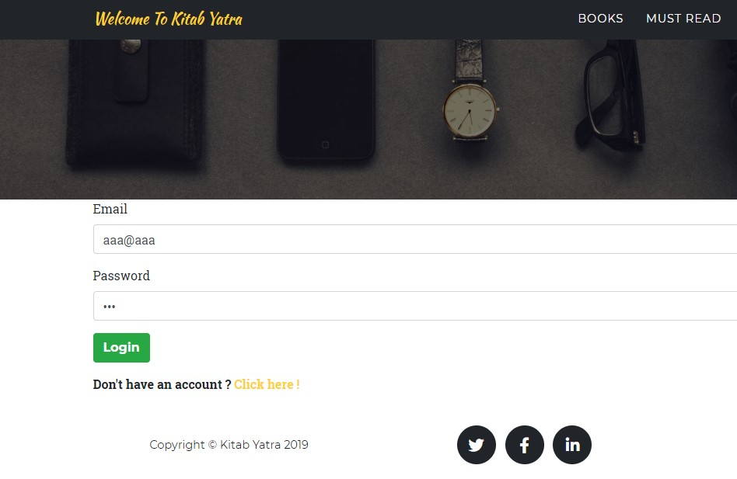

***Fig 33: Login with email "aaa@aaa"***

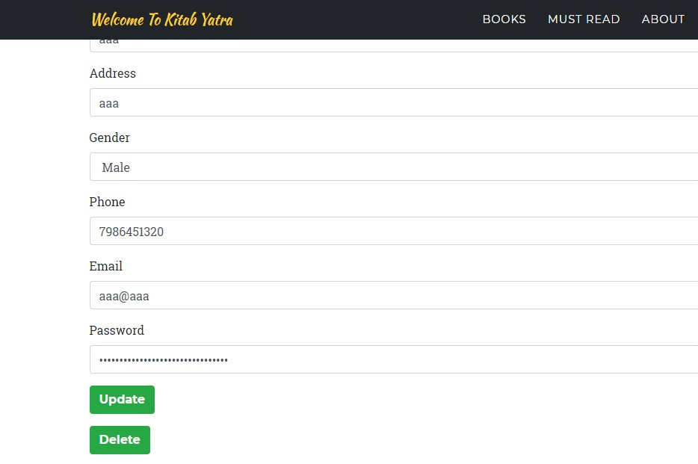

***Fig 34: detail about "aaa@aaa"***

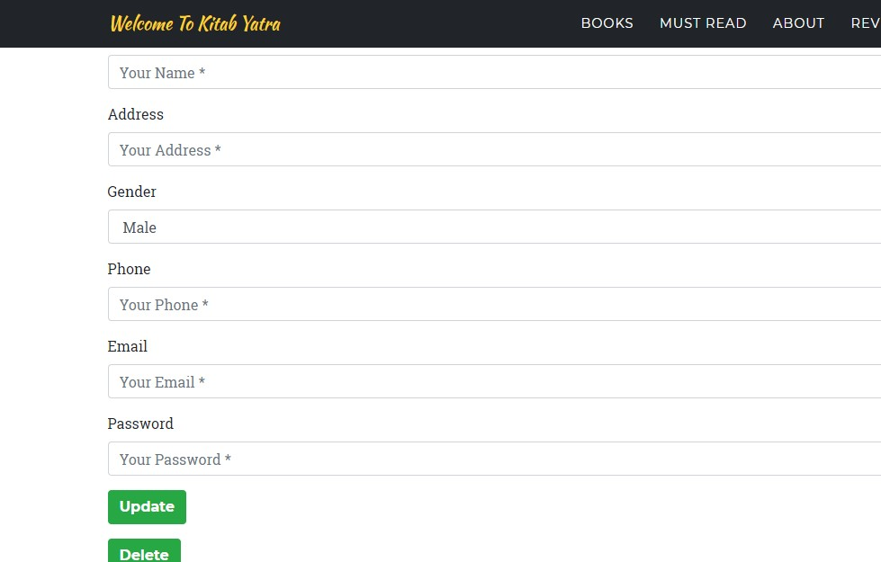

***Fig 35: After Delete button is clicked all data is deleted***

20. Checking the deleted user



***Fig 36: Checking the deleted user with same email and password***



***Fig 37: Error message appeared***

* 1. **Unit Testing:**

That type of testing in which the individual material or the components are tested is called as Unit testing. This type of testing is done to know whether the each unit of the project is performed as it is designed or not. It is generally performed by the white box testing.

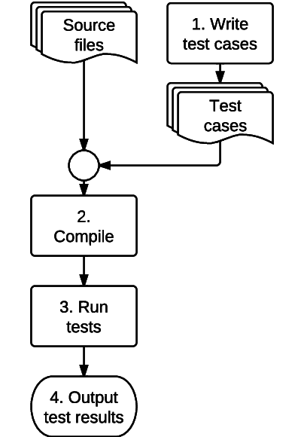

***Fig 38: Unit Testing***

**Test Cases for Unit Testing:**

|  |  |  |  |  |  |
| --- | --- | --- | --- | --- | --- |
| S.N | Test Case | Test Data | Expectation | Actual Result | Date |
| 1 | Register should be done. | Registration | Must be register | Unsuccessful | 7/1 |
| 2 | Registration should be done | Registration | Must be register | Successful | 7/1 |
| 3 | Login should be done | Email and password | Must be login | Unsuccessful | 7/1 |
| 4 | Login should be done | Email and password | Must be login | Successful | 7/1 |
| 5 | Newsletter message should be sent | Phone column | Must be sent | Isn't sent | 7/2 |
| 6 | Newsletter message should be sent | Phone column | Must be sent | Is sent | 7/2 |
| 7 | Order should be done | Book order | Must be order | Isn't ordered | 7/2 |
| 8 | Order should be done | Book order | Must be order | Is Ordered | 7/2 |

***Table 2: Test cases for unit testing***

Here is my all Unit tests:

Failed Tests:

1. Registration test

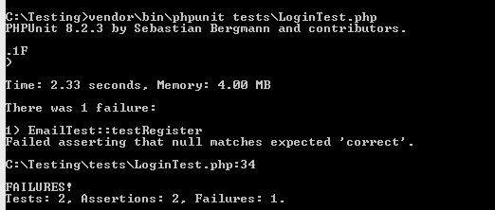

***Fig 39: Failed Registration test***

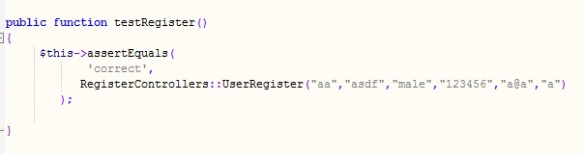

***Fig 40: Code for registration testing***

Passed Codes:

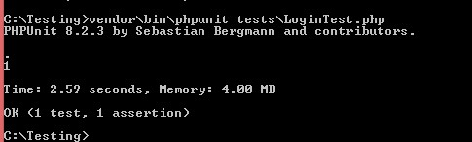

***Fig 41: Passed Registration Code testing***

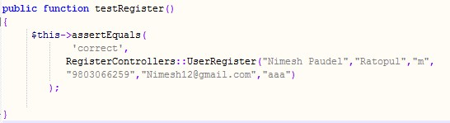

***Fig 42: Passed registration code***

1. Login Test

Failed Login code:

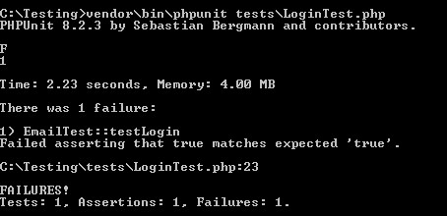

***Fig 43: Failed Login test***

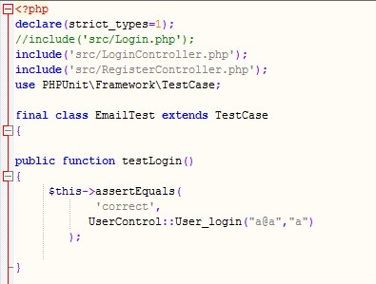

***Fig 44: Code of Login testing***

Passed Login codes:

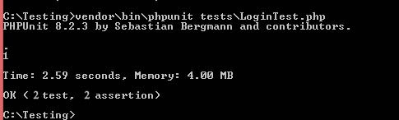

***Fig 45: Passed Login Code***

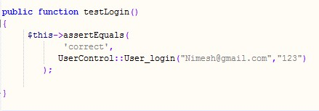

***Fig 46: Passed login code***

1. Newsletter adding test

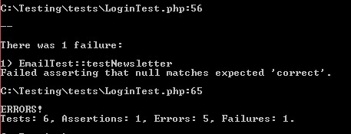

***Fig 47: Newsletter test***

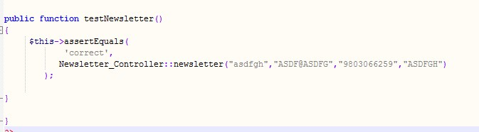

***Fig 48: Code for newsletter testing***

1. Order Test

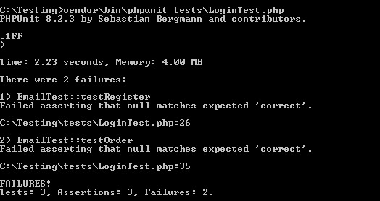

***Fig 49: Order test***

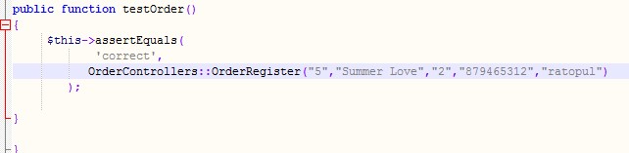

***Fig 50: Code for order testing***

# **Conclusion**

So in this way the project of mine will be completed in the mean time. My project is based on the online book ordering management system for the organization called Kitab Yatra. As I have mentioned in above, the project will be made with the help of PHP and its supporting tools. The aim of my project will be to make a good website for the readers of Nepal with the supporting features and that can be easy to use.

I have also divided the time on the above section which will help to touch the milestone in the meantime. I have taken the waterfall model to develop my project by analyzing the scenario.

I have also classified the risk and its solution in the above section to minimize the errors and to make a standard application of my project.

# **Bibliography**

Toolsqa. (2019). *SDLC Waterfall Model*. [Online] Available at: <https://www.toolsqa.com/software-testing/waterfall-model/> [Accessed 5 April. 2019].

Source making. (2019). *what is Design pattern?* [Online] Available at: https://sourcemaking.com/design_patterns [Accessed 6 April. 2019].

Svitla. (2018). System Architecture. [Online] Available at: <https://svitla.com/blog/web-application-architecture> [Accessed 7 April. 2019].

Gantt. (2019). *What is a Gantt chart?* [Online] Available at: <http://www.gantt.com/> [Accessed 8 April. 2019].

compliance techtarget. (2019). *What is a Risk management?* [Online] Available at: <https://searchcompliance.techtarget.com/definition/risk-management> [Accessed 8 April. 2019].

Stakeholder map. (2002). what is Configuration Management? [Online] Available at: <https://www.stakeholdermap.com/project-management/configuration-management.html> [Accessed 8 April. 2019]